**Gametype**

* **Single Player or Multiplayer? –** Single player StarCraft II campaign
* **Game Type? (DM, Capture the Flag, Assassination, Warfare, Hostage Rescue, Traditional RTS, Platformer, etc.) –** Technically RTS (it will be a squad of three player-controlled units rather than the traditional base-army-micro gameplay)
* **What game is this map for? (UDK, Starcraft II, COD, etc) –** StarCraft II

**Story**

* **Story behind your map. Why are the players there? Why is the place/environment there? Write the history of your environment. What happened to the place before the player entered the environment? –** The map takes place during Sarah Kerrigan’s (one of the main characters from StarCraft) time with the Sons of Korhal Rebellion before the events of StarCraft I. The map takes place after she decided to switch sides from the Terran Confederacy (the faction the Sons of Korhal are trying to overthrow which happens during StarCraft I) following the assassination of Angus Mengsk (the father of Arcturus Mengsk – leader of the Sons of Korhal); which Kerrigan carried out. The players/story have been led to the map by order of Angus Mengsk after he received intelligence reports of a hidden, advanced-tech, weapons facility. Mengsk has ordered Kerrigan and her team to sabotage the Terran Confederacy installation in order to cripple the Confederacy, helping the Rebellion and as a form of redemption for the assassination of Arcturus’s father.
* **What is this map about? –** Kerrigan leads a team of two other ghosts (a very strong attack/super weak defensive unit in StarCraft that has the ability to cloak, or turn invisible, along with other recon-esque abilities. I may edit their abilities to add intrigue to the characters) on a covert mission to sabotage a hidden jungle base controlled by the Terran Confederacy.
* **Every player at every map/level has a goal/desire/object and it is either fulfilled or denied/blocked/obstacle. Do you have this? Does it rise? This is especially important in Single Player maps. –** Player will be given the required objectives of: Kerrigan must survive and the player must sabotage the facility. The player will also be given the immediate optional objectives of: Remain undetected (the facility will have built-in detectors that the player will have to navigate passed, along with defensive units, to complete this objective), All members must survive, and you must reach the evac site before the timer expires (there will be an in-game timer for when Mengsk will send an evac shuttle to pick up the team. However, unbeknownst to the player, the shuttle will not make it regardless of beating the timer or not which will then lead them to the next level—not to be completed—in the jungle and foreshadowing Mengsk’s eventual betrayal of Kerrigan during the events of StarCraft I). The player will also receive the following optional objectives pending their discovery of side information: There will be three different pads that correlate to side research/information that pertain to a weapon schematic, a prototype weapon, and the experimentation of forcing Zerg (a hive-mind alien species in the game that acts as the main protagonist) to infest (turns Terrans into Zerg/Terran hybrids; kind of like zombification) Terran civilians (evil experimentations!). Finding one of the bits of information will lead the player to the other two pieces of side objectives/information. The side objective will explicitly be to collect all three pieces of side research to help further the Sons of Korhal’s cause.

**Gameplay**

* **What is the objective of your map? –** Make it to a central assembly core, sabotage the core, which destroys all production within the facility and make it out to the extraction point alive.
* Do you have a top down game play sketch?
* **Will there be any puzzles? If so, what are they? –** The only “puzzle” will be a navigation “puzzle” in which the player will need to design and traverse depending on how they want to tackle the level.
* **How would the level play out? Gameplay wise? –** It will be a squad based map where the player will need to strategize and use caution to beat the level if they want to have all three ghosts survive.
* **How would you want the player to play through your map? Visualize this. What experiences do you want the player to walk away with from your map? –** I want the player to have an exciting experience where the tension of death is very real since ghosts are relatively weak (HP/Defense) which will encourage them into being cautious and strategic. However, if the player wants to take on enemies head-on they can, but it the risk is losing one or two of their units. I also want the player to enjoy the story as StarCraft players have never been able to experience a non-Zerg infested Terran story (sans three levels in StarCraft I, which is weird because she is such a beloved and integral character in the StarCraft Universe). My intent is that the story enjoyment will come from the side objectives foreshadowing the betrayal of Mengsk which leads to Kerrigan become infested and one of the main antagonist/protagonists of StarCraft I/II.
* **How big is the map? –** I am going to start with an 88 x 88 sized map because that seems to be the standard size and I have yet to find a correlation between the dimensions and real-world measurements. However, I may adjust it based on gameplay testing.
* **Who is your audience? Who is your player? What is your Demographic? –** Fans of StarCraft I/II and single RTS fans in general.
* **How will you make the map memorable? –** Via the incorporation of foreshadowing/story and tying it in to the StarCraft canon along with enjoyable RTS gameplay.
* **Do you have basic top down view and few location concept sketches? -**

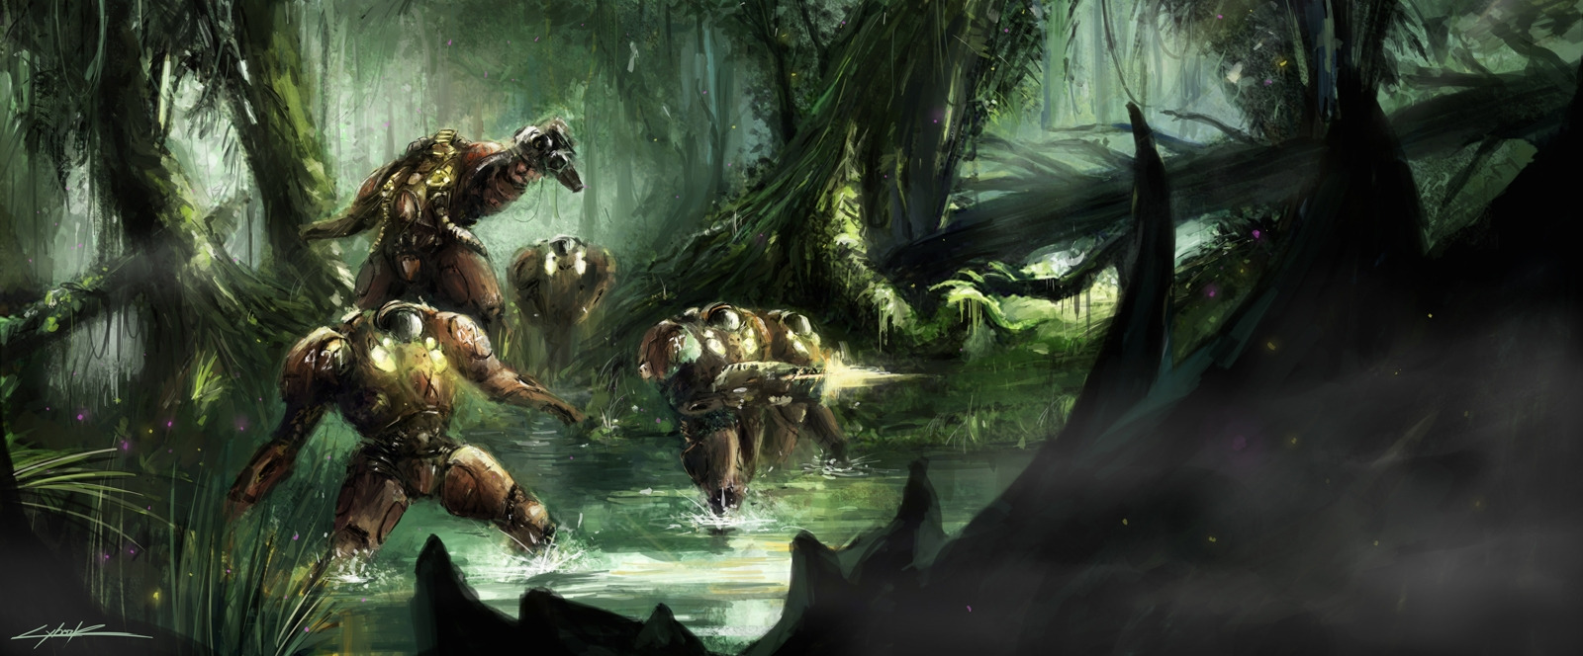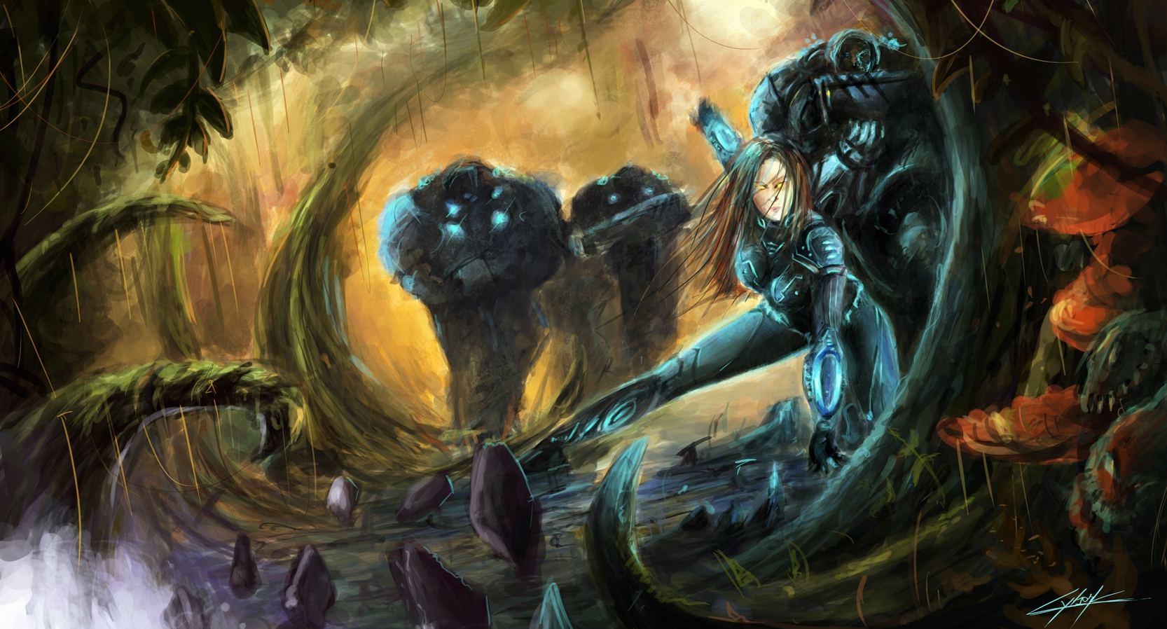

**Visuals**

* **Is the map original? What is everyone else doing? Don't make another "everyone" map. Be original and different. How will you achieve this? –** Most StarCraft maps revolve around the army/base micro-management style of gameplay so this is a refreshing change on the standard map even though there are maps similar in objective gameplay in StarCraft I, but they are very few and far between, redundant, and bland. This kind of map is non-existent in StarCraft II so it will definitely be an original experience that does not feed into the “everyone RTS symmetrical map”.
* **Reference. Have you collected all the inspiration and research? What is this going to look like (proof of visual development). -**

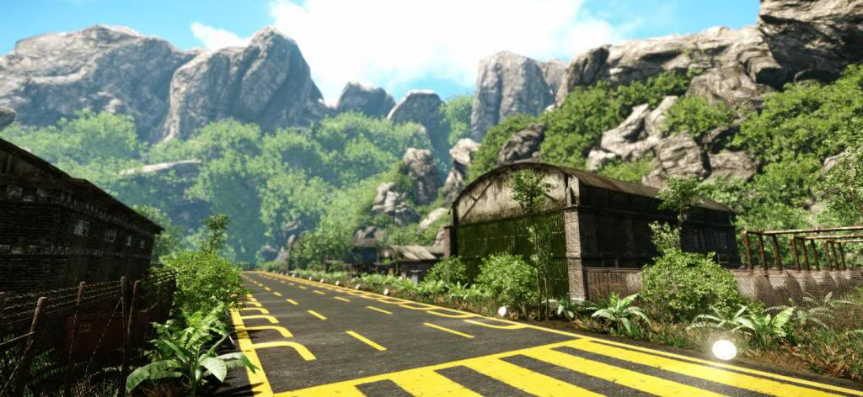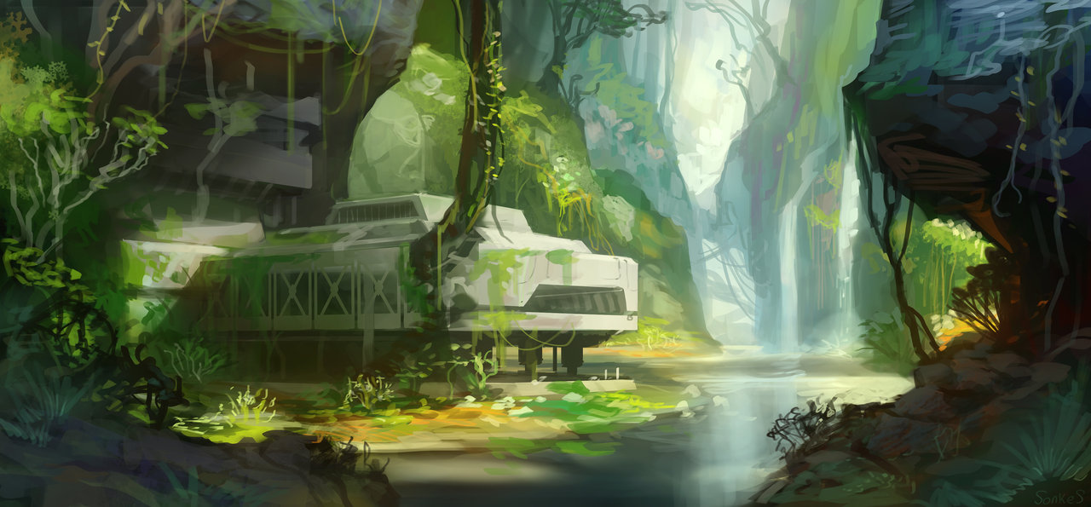

* **What is the time of day of the map? Season? Color? Reference. -**

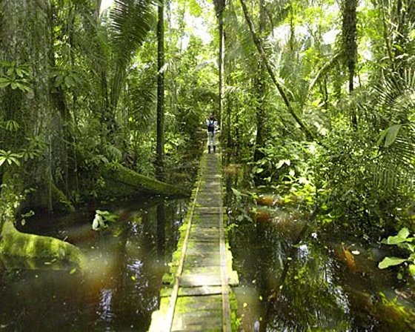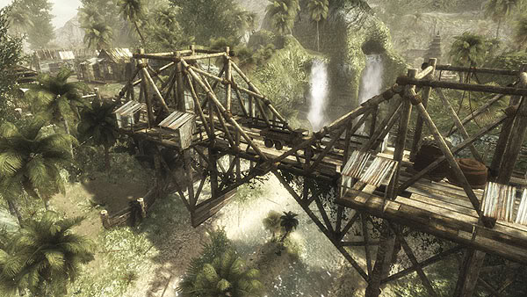

* **Feel and Atmosphere. Describe what you want to portray in terms of the feel of the map and atmosphere. -** Stressful covert spec-op mission in an unfamiliar planetary jungle and hostile military base.
* **Will exploration be rewarded? If so what will it be and in what way? -** Players will receive a deeper story and bonus objectives for increased score/completion. As well as alternate routes for a wider array of options for completing the level.
* **How will you direct the player? What methods will you use? Color? Noise and Sound? Guide the player without telling them where to go. Smart design. -** I will direct the player via pathing, enemy placement, and objective triggers.
* **What are you going to concentrate on? What do you want to learn when you are finished? What aspect of design, gameplay, fun, crazy, atmosphere? -** I am going to concentrate on making a polished level that could be incorporated into an actual StarCraft game (or similar game) to show off my skills as a level designer for use in my professional portfolio. The greatest concentration will be placed on set design to create an interesting and fun environment for the player to play in and enjoy a possible back story of one of the main characters in the StarCraft universe.
* **What is the visual trademark of your level? How will the players remember your map? -** The foreshadowing visual elements of my level will make it memorable along with the jungle environment which isn't really seen in the single player side of StarCraft.
* **Are the environments/locations too generic? How does their design strengthen the story? -** The only spec-op type missions that are featured in StarCraft/StarCraft II take place on a space ship so bringing that type of gameplay to a jungle planet is a strong design choice. The decision to meld the environment with the story I created strengthens the overall gameplay by bringing in several different well-received components and creating something new with them.
* **Custom content? Textures, Models etc. If so, what are they. -** I will be using pre-created units already in the editor; however, I will be creating a special instance to change their names, stats, and custom scripts to make the level work correctly.
* **Have a drawn map of the level, below is an example:**

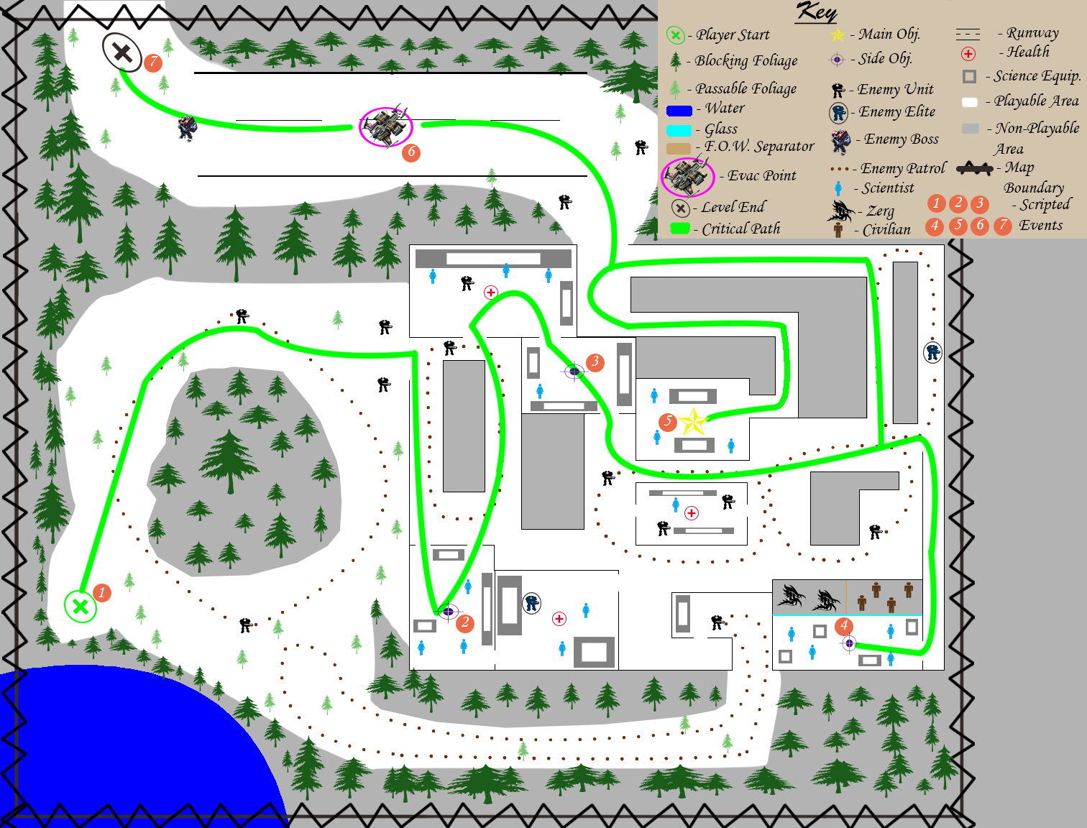

* After this you should have a very clear mental picture of your map, including reference and inspirational material.

**References for Prior Art Used**

http://s.cghub.com/files/Image/304001-305000/304189/036_max.jpg

http://fc09.deviantart.net/fs70/f/2011/325/d/8/starcraft_2_heart_of_the_swarm_jungle_by_vitoss-d4gvo3w.jpg

http://s1355.photobucket.com/user/pianopolish2/media/Editor2013-06-0814-46-22-91_zps7bf8d061.jpg.html

http://fc06.deviantart.net/fs70/i/2013/104/f/1/jungle_base_by_real_sonkes-d61o7lx.jpg

http://www.messagetoeagle.com/images/amazonjungle.jpg

http://s269.photobucket.com/user/Enamelized420/media/COD5-banzai2_screenshot_600.jpg.html