Derek Sinex

GAM175

Tactibru Game Test

University of Advancing Technology

Matt Marquit

1. **Windows played in Windowed Mode – HUD clips through building on level 1**

**Severity:** Low

**Type:** Interface

**Description:**

The bottom two boxes (Turn and Mini-Map) of the HUD clip through the building on level one when they hit some sort of collision or art layer in the building’s roof. *A similar bug happens with all character models, in original position, with the Mini-Map.

**Steps:**

1. Load Level 1
2. Move mouse to scroll main map/viewer so that the Turn and Mini-Map pieces of the HUD move into the building.

**Rate of Reoccurrence:** 15 out of 15

**Screenshot(s):**

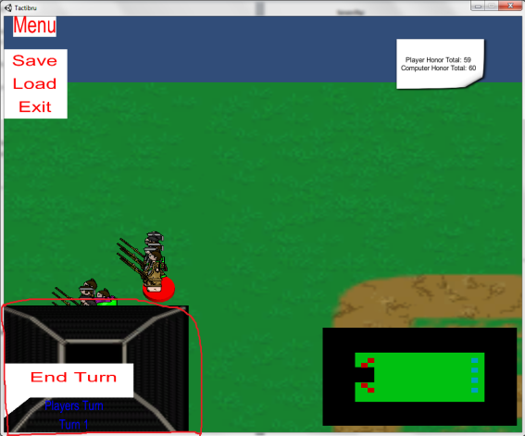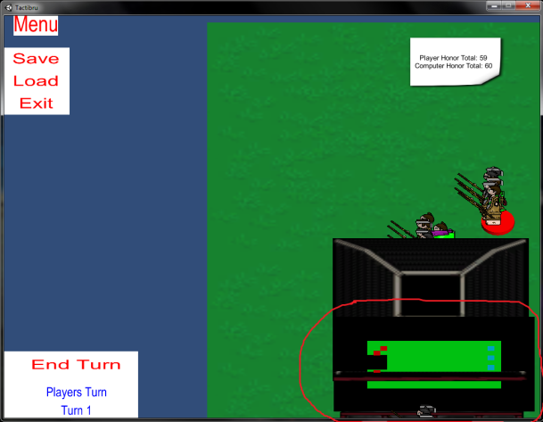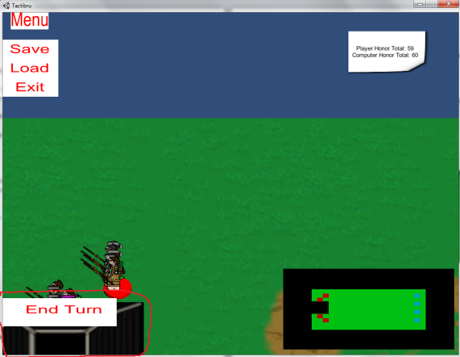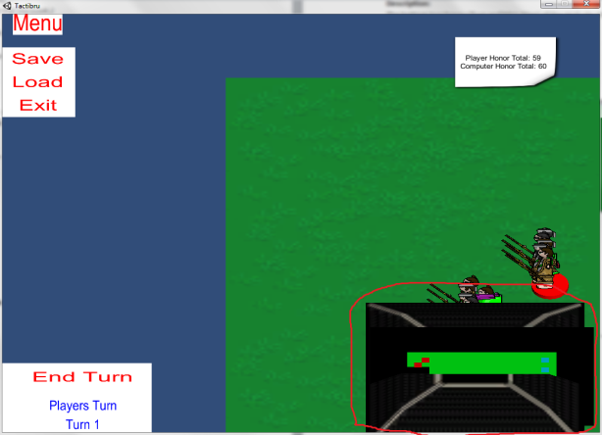

--------------------------------------------------------------------------------------------------------------------------------

1. **Windows played in Windowed Mode – Player must move to a location before attacking computer**

**Severity:** Medium

**Type:** Function

**Description:**

While the computer can directly attack the player if the units are within their range/movement lattice, the player must always move to a location then while the unit is still highlighted, they are able to attack the computer if they are within the unit’s range/movement lattice.

**Steps:**

1. Select unit that has an enemy in its range.
2. See that any enemy units in range do not have a blue block underneath them
3. Move to any blue block.
4. See blue block underneath enemy unit as long as they are still in range.
5. Click on enemy unit to attack.

**Rate of Reoccurrence:** 43 out of 43 – occurs on every level

**Screenshot(s):**

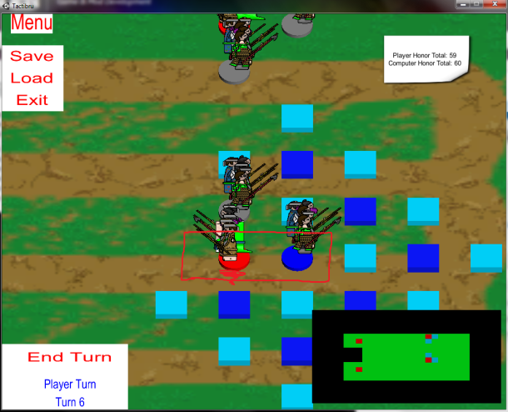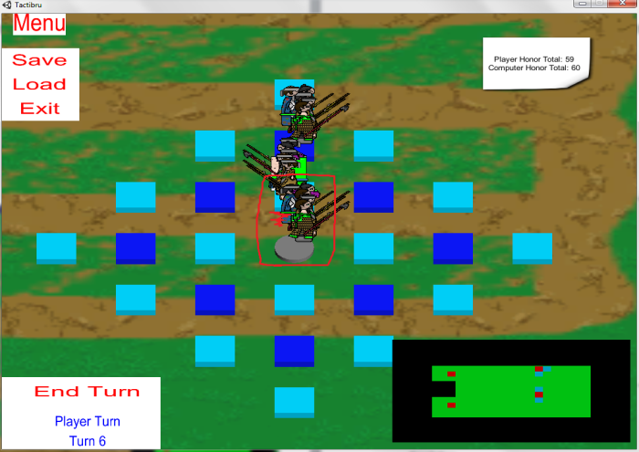

--------------------------------------------------------------------------------------------------------------------------------

1. **Windows played in Windowed Mode – Exit Button on Main Menu Screen does not work**

**Severity:** High

**Type:** Function

**Description:**

When pressed, the exit button on the main menu does not do anything. While in full screen mode, the use must alt+tab in order to close the game.

**Steps:**

1. From any screen (I.E. start-up, level menu -> main menu, etc.) go to main menu
2. Click on “EXIT” button

**Rate of Reoccurrence:**  20 out of 20

**Screenshot(s):** n/a

--------------------------------------------------------------------------------------------------------------------------------

1. **Windows played in Windowed Mode – “Menu” title/button out of frame**

**Severity:** Low

**Type:** Interface

**Description:**

The “MENU” title button inside of the level select menu is cut off so only “enu” is displayed.

**Steps:**

1. Click on “Play” from main screen
2. See “enu” being displayed on the far left instead of “Menu”

**Rate of Reoccurrence:** 37 out of 37

**Screenshot(s):**

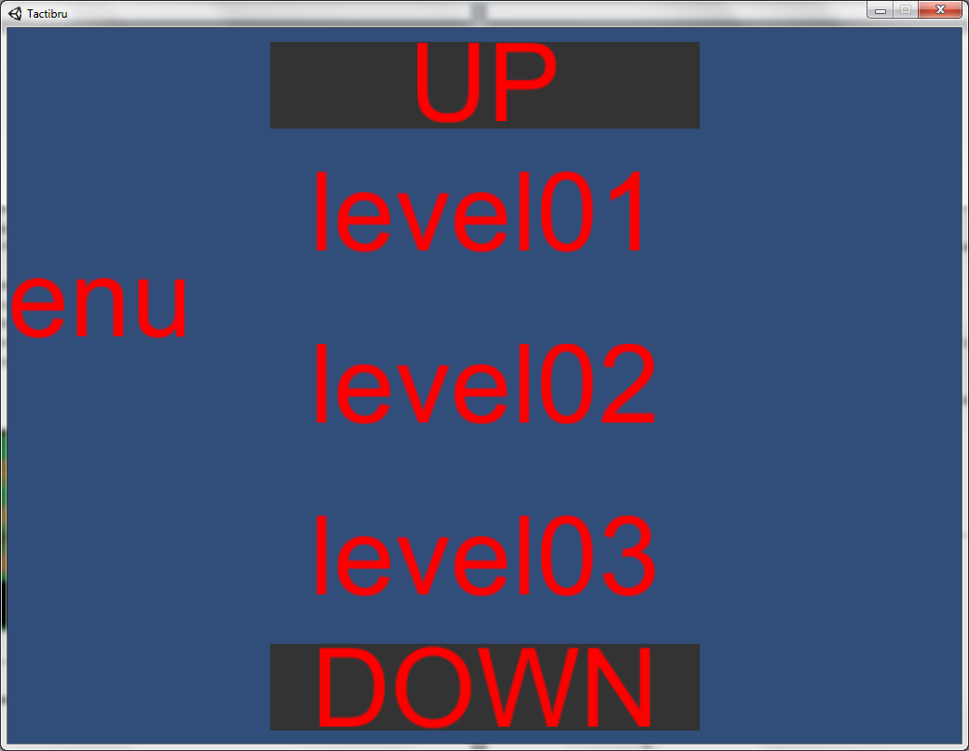

--------------------------------------------------------------------------------------------------------------------------------

1. **Windows played in Windowed Mode – Level 2, 3, 5, 6, 7, 8, 9 computer runs out of places to move**

**Severity:** Urgent

**Type:** Checking

**Description:**

On level two, the computer only moves units that can move directly forward without running into the fence collision. After three turns, the computer runs out of free pathing areas and just sits idle. (In levels 6, 7, 8, 9 it will happen after two turns. In levels 10 and 11 this occurs after two turns only if the player chooses to skip their turns completely)

**Steps:**

1. Play can move their units anywhere within three turns or just skip their turn
2. Computer will move its three available units forward in a straight line for three turns
3. All computer controlled units have some type of collision directly in front of them so it will sit idle indefinitely

**Rate of Reoccurrence:** 21 out of 21

**Screenshot(s):**

Sorry, it was too hard to screen shot since it deals with animations and the computer moves units relatively quickly

--------------------------------------------------------------------------------------------------------------------------------

1. **Windows played in Windowed Mode – Level 7: After first turn, bottom row units (if still on the bottom row) are cut off the screen sans heads and sword tips.**

**Severity:** Medium

**Type:** Interface

**Description:**

Same as title. This bug makes it a lot more difficult to select units but it is still possible

**Steps:**

1. See full units – heads and bodies for every unit during first turn
2. Move units during first turn or skip turn
3. See players still appear fully on mini-map
4. Only heads can be seen for bottom row units

**Rate of Reoccurrence:** 18 out of 18

**Screenshot(s):**

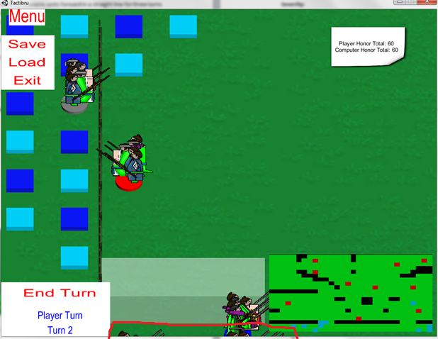

--------------------------------------------------------------------------------------------------------------------------------

1. **Windows played in Windowed Mode – Computer goes idle after losing units in battle**

**Severity:** Urgent

**Type:** Algorithm

**Description:**

I was only able to do this in level 1 and 11 as the computer tends to go idle whenever it starts to lose. However, it occurs whenever the player successfully kills one of the computer’s units

**Steps:**

1. Use all player units to attack the weakest computer unit group
2. Successfully kill every unit in the computer’s unit group
3. Sit and watch the computer stall on its turn indefinitely

**Rate of Reoccurrence:** 6 out of 6

**Screenshot(s):**

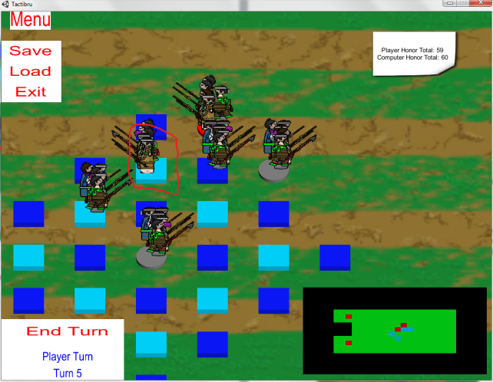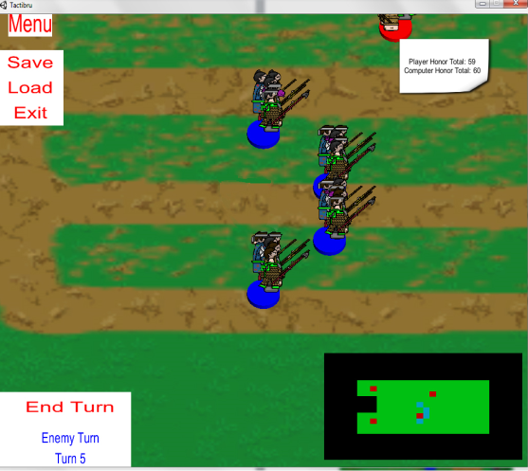

--------------------------------------------------------------------------------------------------------------------------------

1. **Windows played in Windowed Mode – Level 1: Unit art faces the wrong direction**

**Severity:** Low

**Type:** Interface

**Description:**

This bug is most likely due to re-using art/animation assets throughout the entire game. However, level one is the only level where the player units are on the right and the computer units are on the left. This causes the unit art to face the wrong direction.

**Steps:**

1. Load level
2. See unit art facing opposite directions

**Rate of Reoccurrence:** 57 out of 57

**Screenshot(s):**

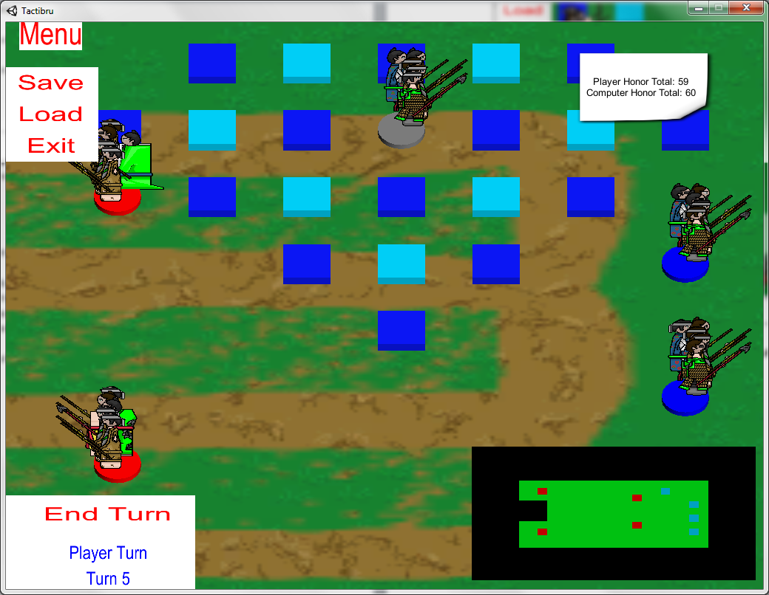

--------------------------------------------------------------------------------------------------------------------------------

1. **Windows played in Windowed Mode – Level 11, player can attack through place-holder collision/fences**

**Severity:** Urgent

**Type:** Function

**Description:**

As long as an enemy is within the player unit’s attack/move lattice, they can attack the computer through place holder collision

**Steps:**

1. Move player units within range on opposite side of collision
2. Click on target computer to attack

**Rate of Reoccurrence:** 7 out of 7

**Screenshot(s):**

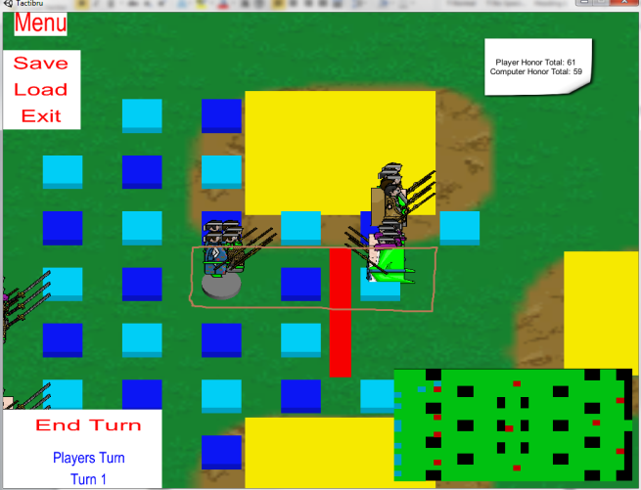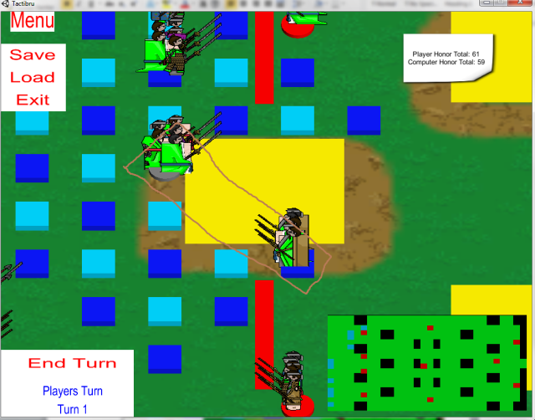

--------------------------------------------------------------------------------------------------------------------------------

1. **Windows played in Windowed Mode – Level 10, hidden art clip through collision placeholder**

**Severity:** Low

**Type:** Interface

**Description:**

In level 10, when the player moves their units directly next to placeholder collision, the hidden background layer of the units clips on top of the placeholder collision. This only* occurs in the two spots pictured above.

*I was only able to make it to turn five before the computer decided to go idle indefinitely. So, I cannot confirm whether it happens anywhere else in the level

**Steps:**

1. Select unit
2. Move unit to movement block directly next to collision
3. See art clipping

**Rate of Reoccurrence:** 12 out of 12

**Screenshot(s):**

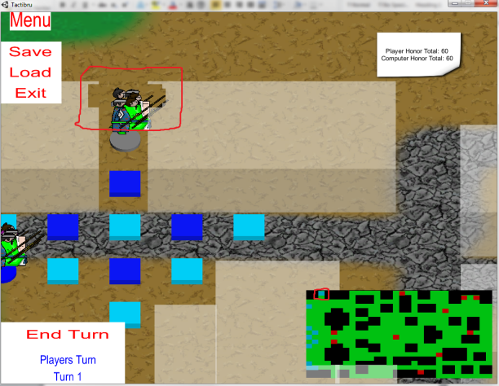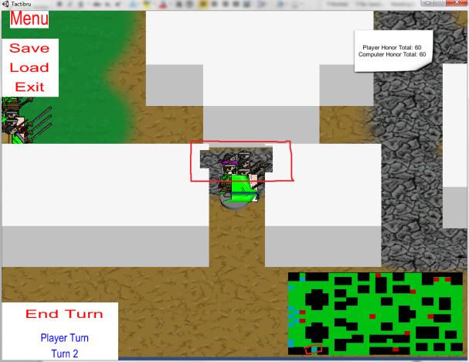

--------------------------------------------------------------------------------------------------------------------------------

1. **Windows played in Windowed Mode – Map Scroll Speed Levels 6, 7, 8 and 9**

**Severity:** Medium

**Type:** Timing

**Description:**

The map scroll speed in levels 6 through 9 is significantly slower than it is in the rest of the levels, almost to the point where the map scrolls half as fast. I’m not sure if this was intentional or not, but it is a little jarring going back and forth from two different speeds

**Steps:**

1. Load level
2. Move mouse to out limits of screen
3. Watch map scroll

**Rate of Reoccurrence:** 37 out of 37

**Screenshot(s):** n/a

--------------------------------------------------------------------------------------------------------------------------------

1. **Windows played in Windowed Mode – Level 9 mini-map/map discrepancy**

**Severity:** Medium

**Type:** Interface

**Description:**

Some of the collision blocks that are on the main map do not appear on the mini-map

**Steps:**

1. Load level 9
2. Scroll to areas with thin collision boxes
3. See collision in main map area, but not displayed on the Mini-Map

**Rate of Reoccurrence:** 14 out of 14

**Screenshot(s):**

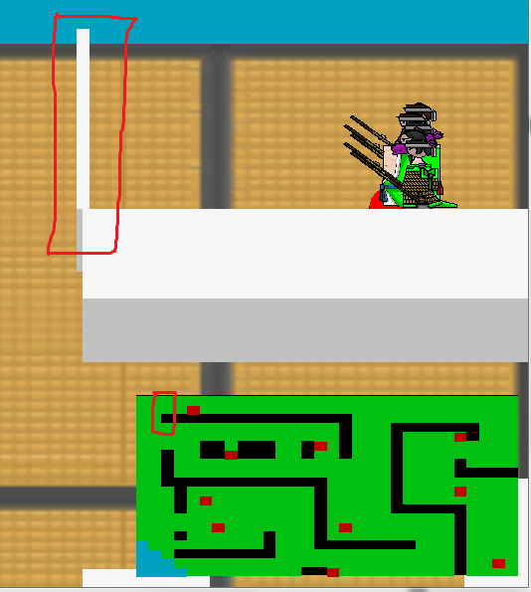

--------------------------------------------------------------------------------------------------------------------------------

1. **Windows played in Windowed Mode – Level 9 art asset**

**Severity:** Low

**Type:** Interface

**Description:**

The art asset for the unit displayed below on level 9 includes a floating area of art that is not attached to any character. It appears to be the coat-tails of one of the large green units.

**Steps:**

1. Load Level
2. Scroll to unit cluster
3. See top-most unit
4. Scroll to left edge of map
5. See misplaced art

**Rate of Reoccurrence:** 23 out of 23

**Screenshot(s):**

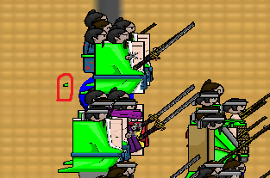

--------------------------------------------------------------------------------------------------------------------------------

1. **Windows played in Windowed Mode – Level 9: Only one computer unit will move**

**Severity:** High

**Type:** Assignment

**Description:**

In level nine, the computer will only move one of its units. This unit only moves downward towards the human player’s units but stops when it gets to the collision. On its second turn, the computer will switch to a unit already facing collision and go idle indefinitely. See below for the only unit that will move

**Steps:**

1. Load level
2. Either move player units as you wish or simply skip your turn
3. See computer move it’s one unit group
4. Either move player units as you wish or simply skip your turn
5. See different unit focused on and computer sits idle

**Rate of Reoccurrence:** 20 out of 20

**Screenshot(s):**

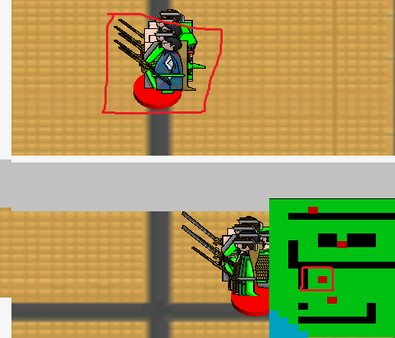

--------------------------------------------------------------------------------------------------------------------------------

1. **Windows played in Windowed Mode – Level 8 Unit Selection Animation**

**Severity:** Low

**Type:** Interface

**Description:**

In level 8, the long robed characters float through the circle base during the selection animation.

**Steps:**

1. Load level
2. Select proper unit
3. See character’s clothes clip in and out of the unit base

**Rate of Reoccurrence:** 12 out of 12

**Screenshot(s):**



