Lou's Adventure

*Game Design Document*

*Derek Sinex*

*University of Advancing Technology*

# 1. Table of Contents

1. Table of Contents
2. Technical Section
   1. PC
   2. [File & Code Naming Conventions](#_2.2._File_&_Code Naming Conventions)
      1. Stencyl
   3. UI/UX Conventions
      1. Fonts Used
      2. [List of GUI components and configurations](#_2.3.2._List_of_GUI components and c)
3. Introduction
   1. High Concept
   2. Game Description
      1. Summary
      2. Genre
      3. Target Audience/Key Demographic
      4. Game Flow/Pacing
      5. Artistic Direction
         1. Insert a concept image here
      6. Project Scope/Development Cycle
   3. Key Features
      1. Control Scheme
         1. Supporting Scheme
      2. Assistive Mechanics
         1. [Supporting Key Feature](#_3.3.2.1._Supporting_Key_Feature #2)
      3. [Color Coding](#_3.3.3._Color_Association_with Speci)
4. Background/Story
   1. Plot Outline
   2. World Environment
   3. Character Bios
      1. Lou
      2. Rory
      3. Janet
      4. Lou's Dad
      5. Lou's Mom
      6. Agatha the Doll
      7. Shirt Snake
      8. Toy Soldiers
      9. Dust Bunnies
      10. Ragdolls
      11. Soap Monster
5. Game Design
   1. Gameplay Summary
      1. Game Progression
      2. Mission/Challenges Structure
         1. Puzzle Structure
         2. Objectives
         3. Mission/Challenge Structure
            1. Game Flow
      3. Controls
         1. PC Keyboard
6. Art & Graphics
   1. Art Asset Breakdown
7. Audio Design
   1. Audio Asset Breakdown
8. Appendices
   1. Technical Design Document
   2. Art Assets

# 2. Technical Section

## 2.1. PC

## 2.2. File & Code Naming Conventions

See Appendix 8.1. Technical Design Document

### 2.2.1. Stencyl

"Stencyl isn't your average game creation software; it's a gorgeous, intuitive toolset that accelerates your workflow and then gets out of the way. We take care of the essentials, so you can focus on what's important - making your game yours." - Stencyl, LLC (<http://www.stencyl.com/features/>)

## 2.3. UI/UX Conventions

See Appendix 8.1. Technical Design Document

### 2.3.1. Fonts Used

TBD

### 2.3.2. List of GUI components and configurations

To be included in Lou's Adventure HUD

* Health Bar/Icons
* Score
* Item (such as key or laundry, etc.)
* Idle controls
* Highlighted controls upon player interaction
* Highlighted controls + on-screen prompt as assistive gameplay mechanic
* Visual feedback on-screen prompt as assistive gameplay mechanic
* Audio feedback on-screen prompt as assistive gameplay mechanic

To be included in Lou’s Adventure UI

* Level Select
* Main Menu
  + Start New Game (Choose Difficulty: Super Fun Mode, Normal, Hard)
  + Load Game
  + Options (Audio, Video, etc.)
  + Quit
* Level Win Screens
* Level Lose Screens

# 3. Introduction

## 3.1. High Concept

Lou's Adventure: A 2D side-scrolling platformer game based around assistive gameplay mechanics to make gaming more accommodating for people with cognitive delays.

## 3.2. Game Description

### 3.2.1. Summary

The goal of this project is to create video game gameplay mechanics that accommodate people with cognitive delays more than traditional mechanics do. The team will accomplish this by creating a user experience (UX) and user interface (UI) that actively assists the player in completing objectives and gives real-time feedback based on player performance.

An example of this mechanic includes: User Interface displaying translucent controls and glowing intractable at all times in order to assist the player. During times of actions, the appropriate action to accomplish the task will glow on the displayed control scheme. To further accommodate player's skill, they will be given in-game feedback based on their performance to encourage positive gameplay and deter from negative gameplay.

### 3.2.2. Genre

Lou's Adventure is a 2D Platformer Puzzle.

### 3.2.3. Target Audience/Target Demographic

The target audience is adults and children with cognitive delays.

This SIP idea stems from experiences shared with a former colleague who works as a care-giver for children and adults with mental delays. A large portion of his clients love video games but in his words, “they mindlessly just push buttons while playing games with no goal because game content is too complex for them to cognitively understand what is going on.” These people love games and they deserve a relevant and understandable game for them.

### 3.2.4.Game Flow/Pacing

The game takes a slower pace than the usual platform to accommodate for cognitive delay.

### 3.2.5. Artistic Direction

The art will be done in a cartoonish manner to reinforce the idea of the game world being inside of Lou’s fantastical imagination.

#### 3.2.5.1. Concept Images

#### 

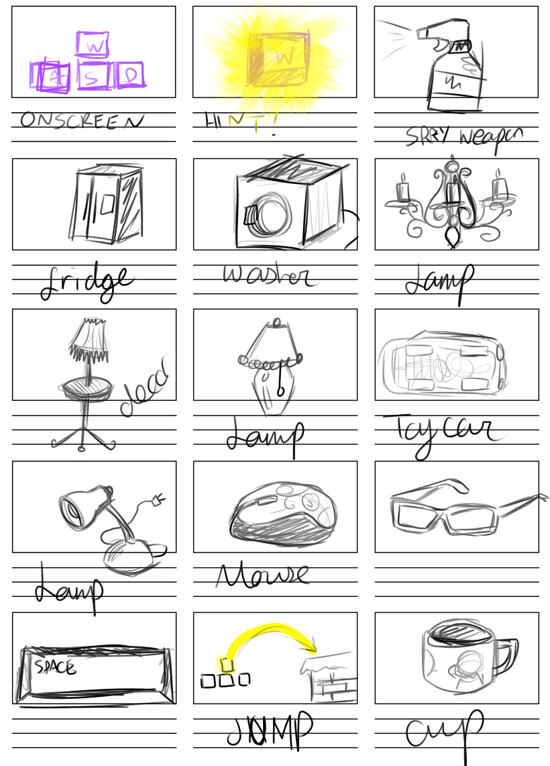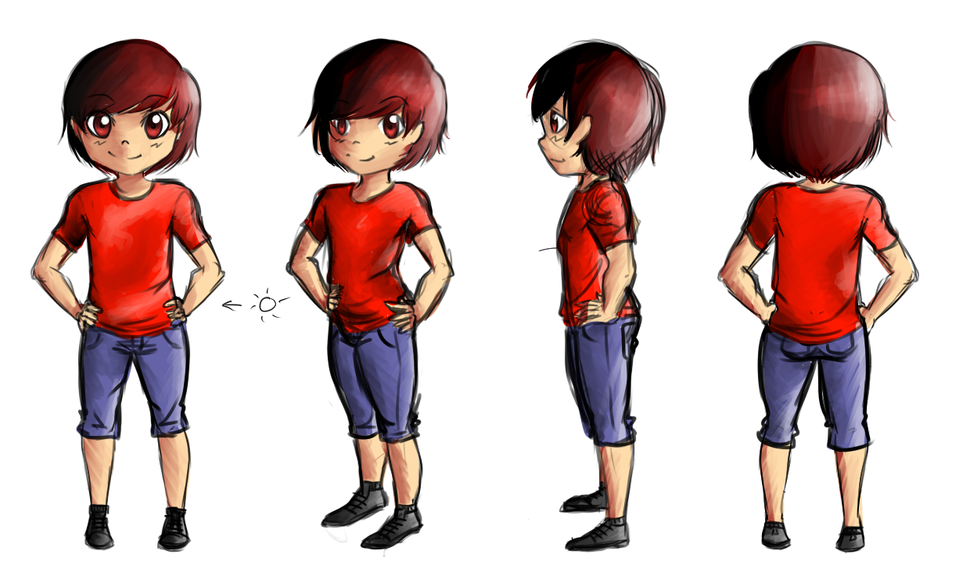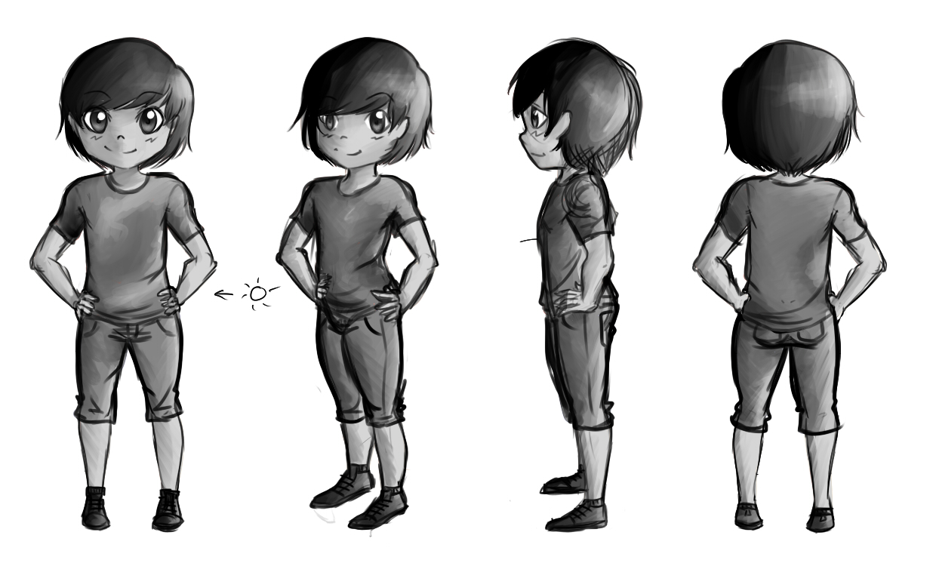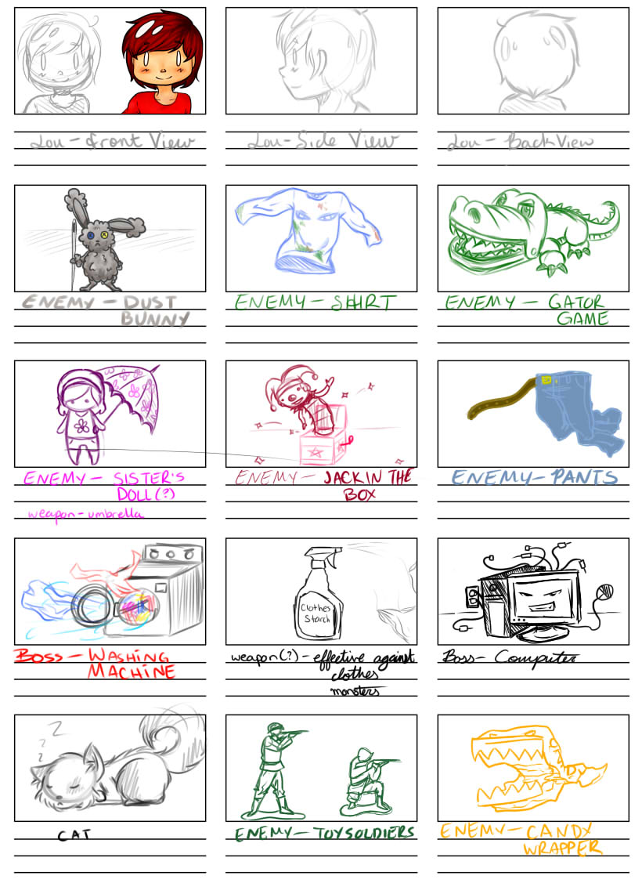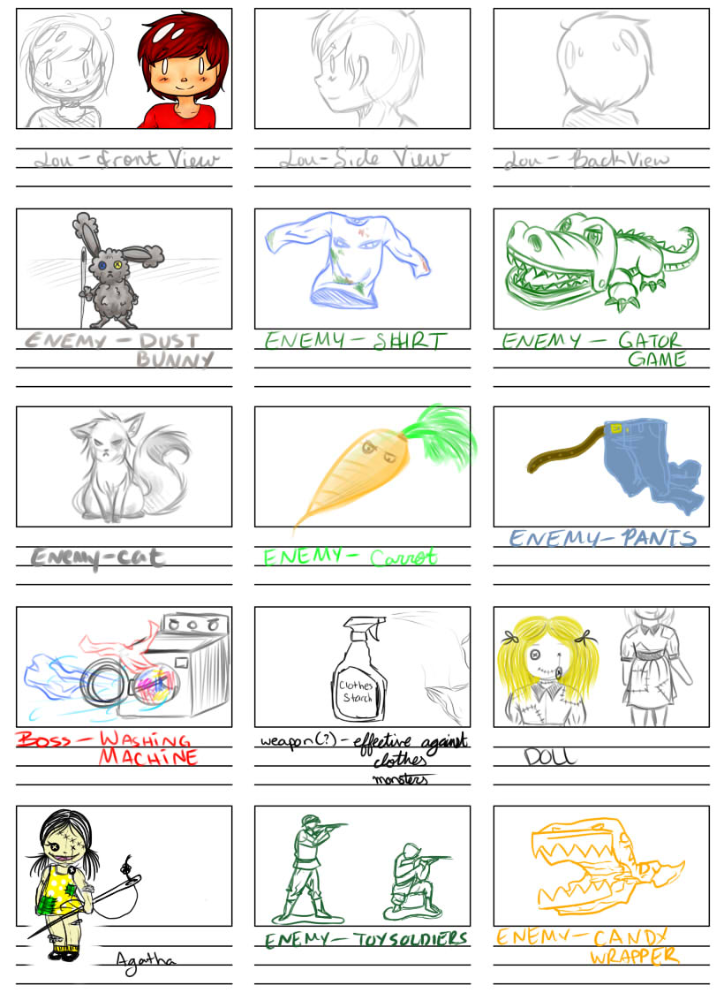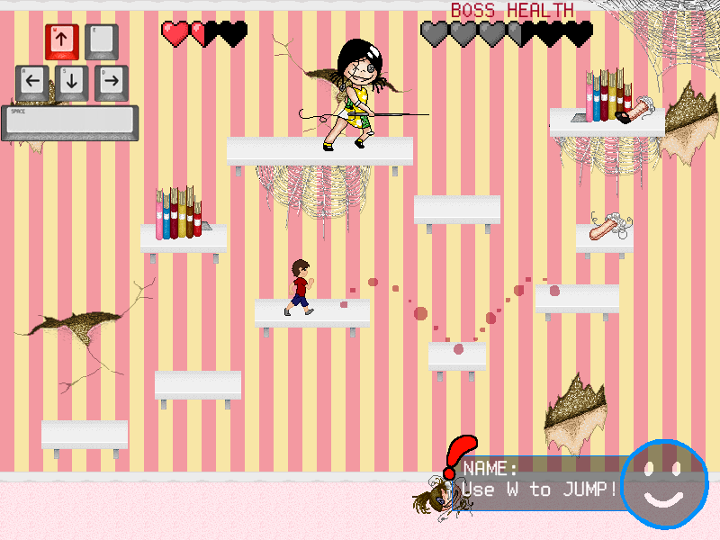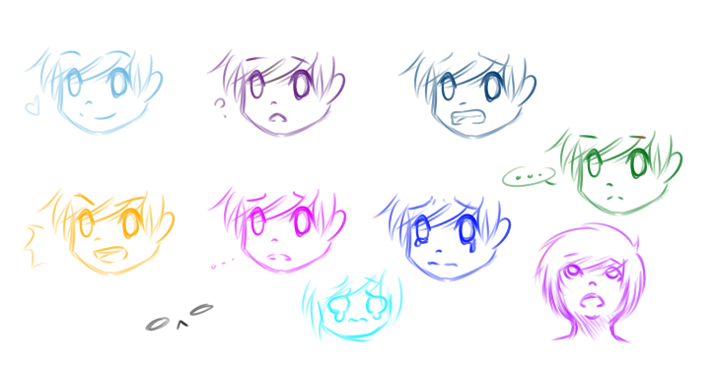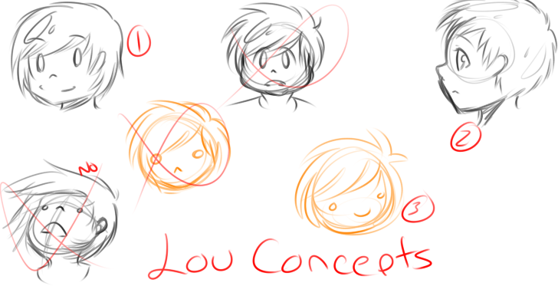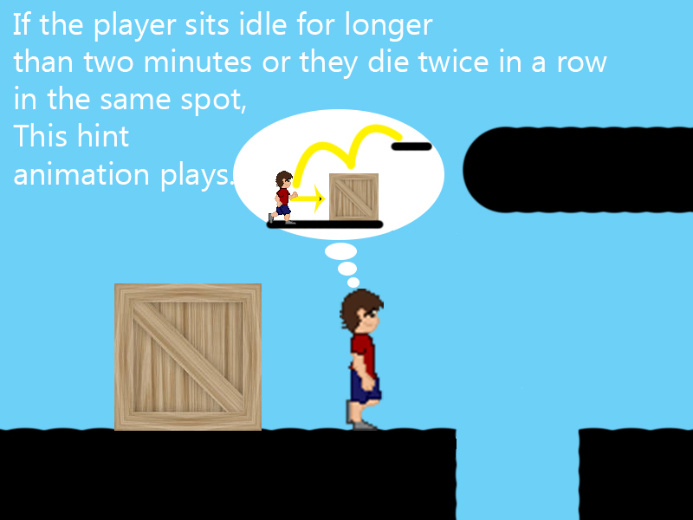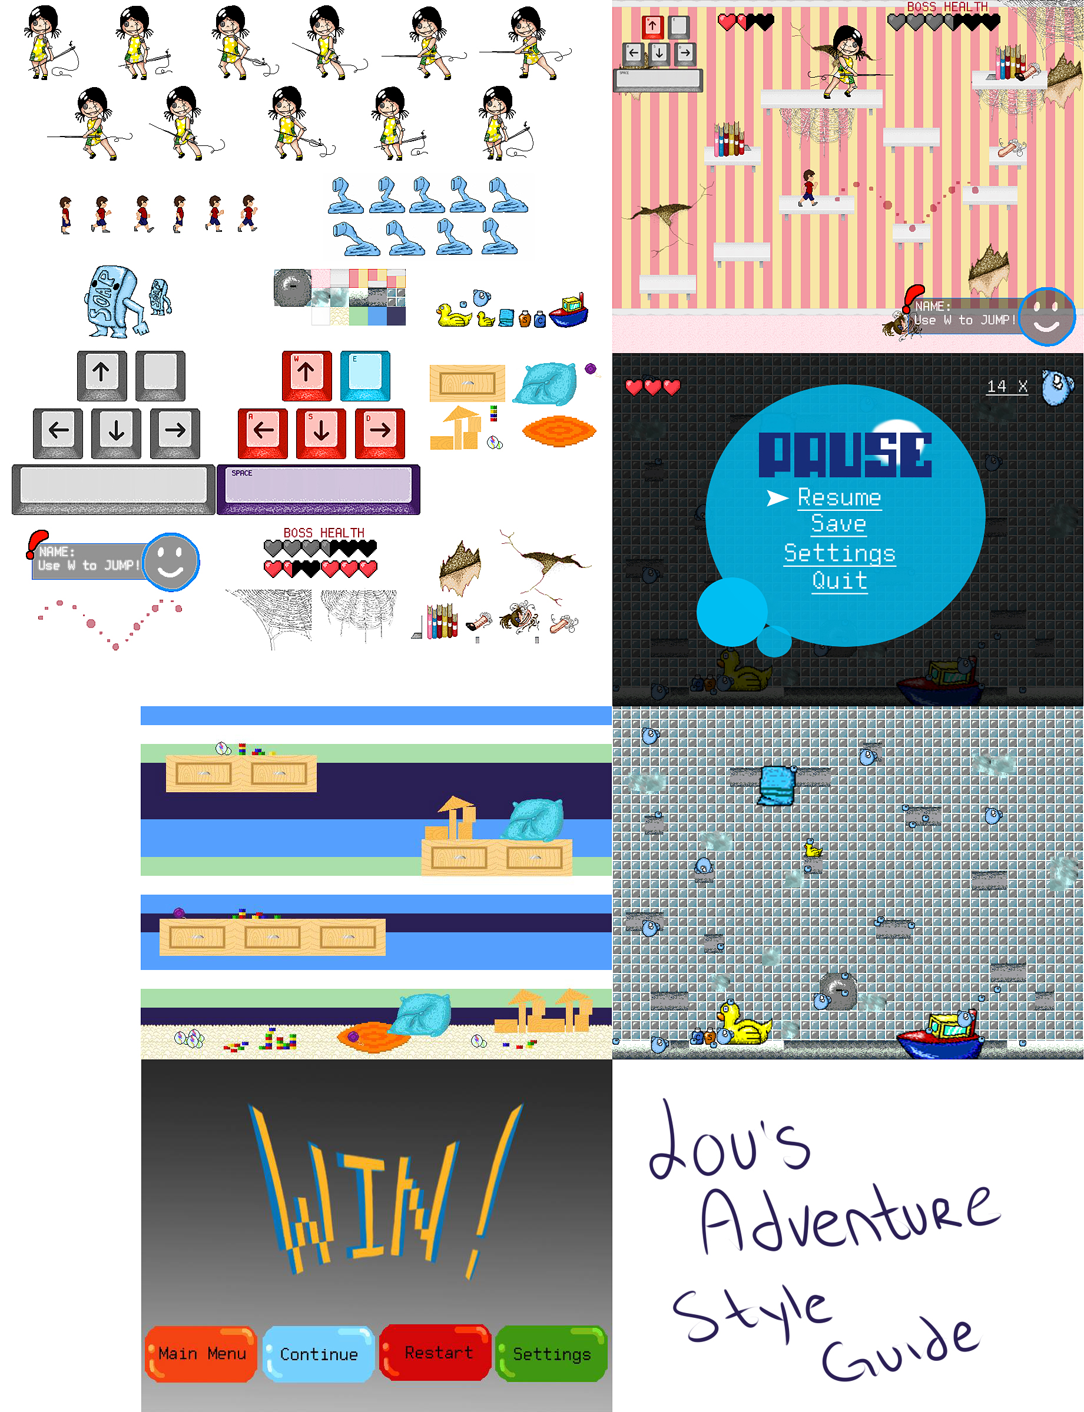

### 3.2.6. Project Scope/Development Cycle

9 Month Development Cycle.

**Number of Locations**

5

**Number of Levels**

5

**Number of NPC's**

14 (tentative)

## 3.3. Key Features

### 3.3.1. Control Scheme

Arrow Keys – Movement (jump, walk right, and left)

#### 3.3.1.1. Supporting Scheme

Player Specific Actions

**Movement**

Simple platformer movement of jump, fall, walk right, and left.

**Interaction**

Used to interact with objectives or activate triggers.

**Combat**

Super Mario “head stomping”

### 3.3.2. Assistive Mechanics

Gameplay mechanics will accommodate people with cognitive delays more than traditional mechanics do. The team will accomplish this by creating a user experience (UX) and user interface (UI) that actively assists the player in completing objectives and gives real-time feedback based on player performance.

#### 3.3.2.1. Supporting Key Feature #1

#### Control Scheme layout displayed at all times.

#### 3.3.2.2. Supporting Key Feature #2

#### A dedicated color scheme that represents assistance from the game; one color for what the player is doing, a different color associated with interactables/pick-ups, a different color associated with enemies, a different color associated with assistive pathing/mechanics.

#### 3.3.2.3. Supporting Key Feature #3

#### If the player is idle for X amount of time or cannot solve a puzzle after X amount of time a thought bubble appears above Lou showing what to do visually with animation as though he is thinking about what he should actually do (in order to assist the player).

#### 3.3.2.4. Supporting Key Feature #4

#### If the player dies twice in a row in the same spot an assistive mechanic activates i.e. showing the correct pathing to follow, positive audio suggestion for what to do, positive text suggestion for what to do.

### 3.3.3. Color Association with Specific Game Objects

**Yellow** – Movement hint (jump here, move there)

**Blue** – Interaction hint (Open this, pick up that)

**Red –** Hostile NPC glow

# 4. Background/Story

## 4.1. Plot Outline

The player takes control of Lou, a young boy with an overactive imagination in their quest to help Lou finish his chores. In the real world Lou absolutely despises doing any type of chore so to better cope and accomplish each task; Lou imagines each scenario as a fantastical adventure that he must endure to be victorious.

## 4.2. World Environment

Players will take on enemies and puzzles in five different locations: His bedroom, bathroom, his sister’s room, the laundry room, and his next-door-neighbor Rory’s house. Each locale contains unique textures, enemies, and collectables for progressing through the game.

## 4.3. Character Bios

### 4.3.1. Lou

As a wide-eyed 6-8 year old, Lou’s imagination takes over much of his life since he is tormented by his next-door neighbor and really has no support system at home. His parents are too busy to give him the time of day, his sister rarely talks to him anymore, and to top it all off; he has a seemingly endless line of chores to do! Essentially, Lou sucks at life. The only way he can get through it is to see his world as a series of adventures that he must triumph over.

### 4.3.2. Rory

Rory is the crazy kid next door. He spends all of his time tormenting everyone he meets because he feels the need to be the boss. Years of manipulation and hyperactivity has given Rory a false sense of superiority and no sense of sharing.

### 4.3.3. Janet

Janet is Lou’s older sister; 6 years his senior. Since she grew accustomed to being the attention-centric only child before Lou came along she has had a hard time adjusting to having a younger brother. The age difference also puts a strain on their relationship as they have drastically different interests. However, she saves face by being nice to her younger brother all the while secretly loathing him. However, her parents decreasing time and attention to either child has pushed Janet to interacting with Lou more than she has for years.

### 4.3.4. Lou’s Dad

Lou’s Dad is a very job oriented person and while he loves his family, business and work always come first. Due to this life approach he has become extremely introverted and only finds solace in reading news articles on his tablet while at home. Even still, all he can think about at work or at home is the W.E.N.I.S.

### 4.3.5. Lou’s Mom

Mom tries to be as loving and attentive to her family as she can. But, growing children means a growing mess. All she seems to have time for now is struggling to keep a clean house and meals on the table. Luckily, she has some free hands; Lou.

### 4.3.6. Agatha the Doll

Agatha is the leader of the ragdolls. She wears a sun-dress. As creepy and evil looking as a cartoon doll can possibly be. Lou projects subliminal feelings of loathing from his sister onto Agatha during the imaginative/alternate reality levels.

### 4.3.7. Shirt Snake

Dirty clothes wriggle and jump around the level as generic enemies. They attack Lou by striking at him as a snake would attack it’s prey.

### 4.3.8. Toy Soldiers

Toy Soldiers in the same vein as actual toy soldiers little kids play with. Generic enemies that march around levels and shoot at Lou.

### 4.3.9. Dust Bunnies

Giant bunnies made of dust. Hop around levels as generic enemies a-la goombas from Super Mario. Essentially the imaginative projection of what dust bunnies would look and act like to a child told to “clean up the dust bunnies” because “they’re taking over the house”.

### 4.3.10. Ragdolls

Generic Enemies. Patched together cloth ragdolls that walk around the level and try to attack Lou when he is within melee range.

### 4.3.11. Soap Monster

Hulking soap bars that attempt to crush Lou within the bathroom level.

# 5. Game Design

## 5.1. Gameplay Summary

## Lou’s Adventure is an Action-Adventure Puzzle game that takes place in an “imagination-world” represented in a 2D pixel art side-scroller as Lou attempts to successfully complete daily chores which present themselves as the game’s objectives.

### 5.1.1. Game Progression

Lou (the player) progresses through a series of levels by walking and jumping around a series of platforms and interacting with the world to complete “chores” or objectives.Each level contains mobs of enemies which need to be defeated and puzzles needed to be solved in order to progress to the next level.

### 5.1.2. Mission/Challenges Structure

#### 5.1.2.1. Puzzle Structure

Puzzles progressively get harder and are comprised of a combination of movement puzzles i.e. moving blocks out of the way to unblock or form a new path in order to get to another part of the level/end of the level. Collecting items, interacting with items, etc.

#### 5.1.2.2. Objectives

Objectives depend on the level but generally incorporate basic platforming and combat to complete.

#### 5.1.2.3. Mission | Challenge Structure

Each level consists of an enemy mob and puzzle equal to the level. For example: Level 1 has one mob and one puzzle that must be completed to advance to level 2. Level 4 has four mobs and 4 puzzles that must be solved to progress to level 5. Etc.

##### 5.1.2.3.1. Game Flow

The game takes a slower pace than the usual platform to accommodate for cognitive delay.

### 5.1.3. Controls

#### 5.1.3.1. PC Keyboard

Arrow Keys – Movement (jump, walk right, and left)

# 6. Art & Graphics

## 6.1. Art Asset Breakdown

|  |  |  |
| --- | --- | --- |
| Asset Name | Priority | Completed? |
| Lou’s Bedroom Background | High | Yes |
| Lou’s Bedroom tiles | High | Yes |
| Lou’s Bedroom Ambient assets | High | Yes |
| Lou’s Bathroom Background | High | Yes |
| Lou’s Bathroom tiles | High | Yes |
| Lou’s Bathroom Ambient assets | High | Yes |
| Janet’s Bedroom Background | High | Yes |
| Janet’s Bedroom tiles | High | Yes |
| Janet’s Bedroom Ambient assets | High | Yes |
| Living room Background | Moderate | Yes |
| Living room tiles | Moderate | Yes |
| Living room Ambient assets | Moderate | Yes |
| Rory’s House Background | Low | No |
| Rory’s House tiles | Low | No |
| Rory’s House Ambient assets | Low | No |
| Lou all sprites | Critical | Yes |
| Rory all sprites | Low | No |
| Janet Assistive Dialogue | Moderate | No |
| Lou’s Dad Assistive Dialogue | Moderate | No |
| Lou’s Mom Assistive Dialogue | Critical | Partially |
| Agatha the Doll all sprites | Moderate | Yes |
| Shirt Snake all sprites | Critical | Yes |
| Toy Soldiers all sprites | Moderate | Yes |
| Dust Bunnies all sprites | Moderate | Yes |
| Ragdolls all sprites | Moderate | No |
| Soap Monster all sprites | Moderate | Yes |
| Shampoo collectables | Moderate | Yes |
| Clothes hamper collectables | High | Yes |
| Sock collectables | Moderate | No |
| Toy collectables | Moderate | Yes |
| Level door objective | Moderate | Yes |
| Health | High | Yes |
| Assistive Pathing Assets | Critical | Yes |
| Assistive Hints Assets | Critical | Yes |
| Assistive Keyboard Assets | Critical | Yes |

# 7. Audio Design

## 7.1. Audio Asset Breakdown

* "Jump" sound file by "Stencyl, LLC"
* "Stomp" sound file by "Stencyl, LLC"
* "Title Theme Adventure" sound file by "Metal Renard"
* "Happy Theme" sound file by "Metal Renard"

# 8. Appendices

## Appendix 8.1. Technical Design Document

Technical Design Document containing all technical specifications for Lou’s Adventure.

## Appendix 8.2. Art Assets Including Concept Art

Folder containing all art assets for Lou’s Adventure. Directory is located on Product Owner’s local machine and can be found on team’s [assembla page](https://www.assembla.com/spaces/lou-s-adventure/tickets).