Tellus Pre-Alpha Play Test
Derek Sinex
University of Advancing Technology
GAM175 Game Testing and Analysis
10/08/2013

Menu Bugs:
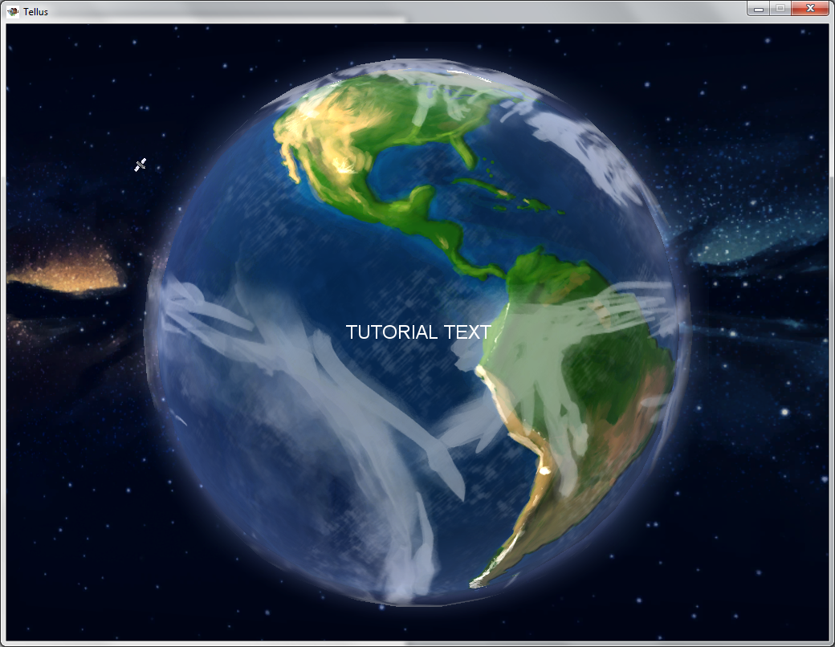
If the player selects “Tutorial”, when the main menu is up; the only thing that is displayed is “TUTORIAL TEXT” and the player cannot go back to the main menu. The player can rotate the Earth by holding down the right mouse button, pushing the WASD, or arrow keys. Severity Rating: Urgent.

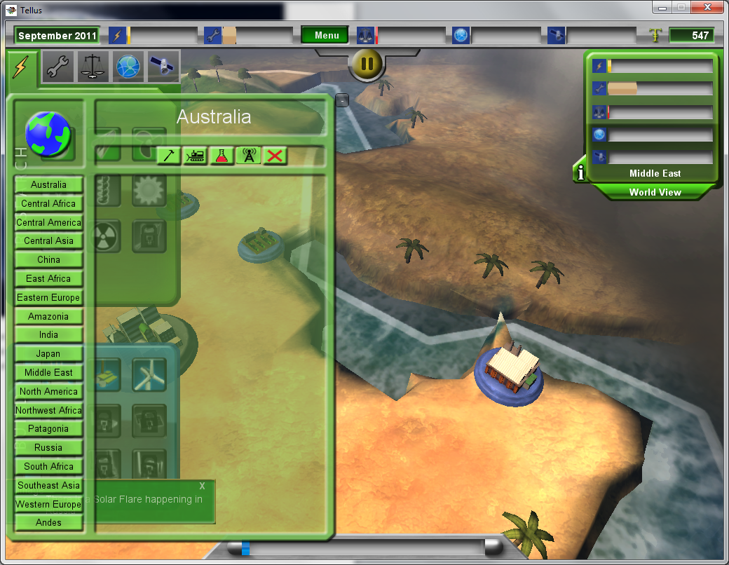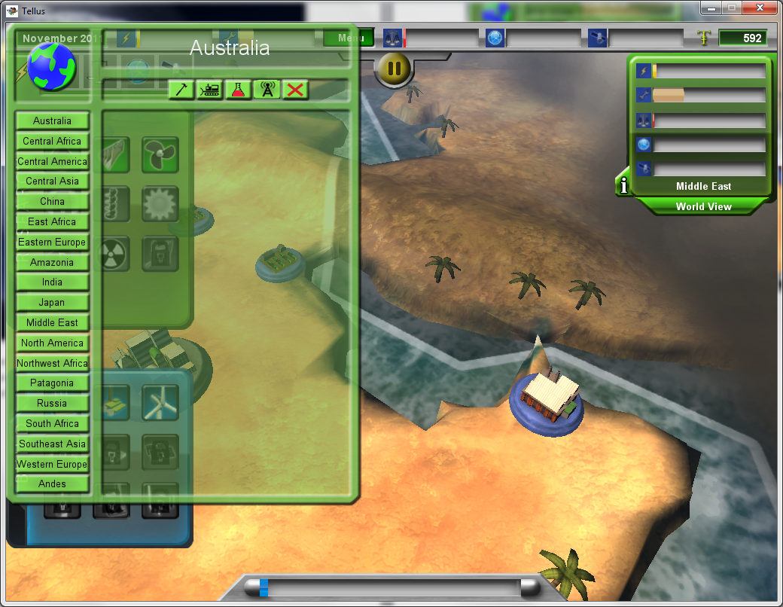
When the player opens the “World happenings report window” there is a collapsible “-“ button (featured in the first screen shot); however, if the player moves the window to any part of the top of the screen the collapsible button is hidden behind the top tool bar making it impossible to close this menu. Severity Rating: Low.
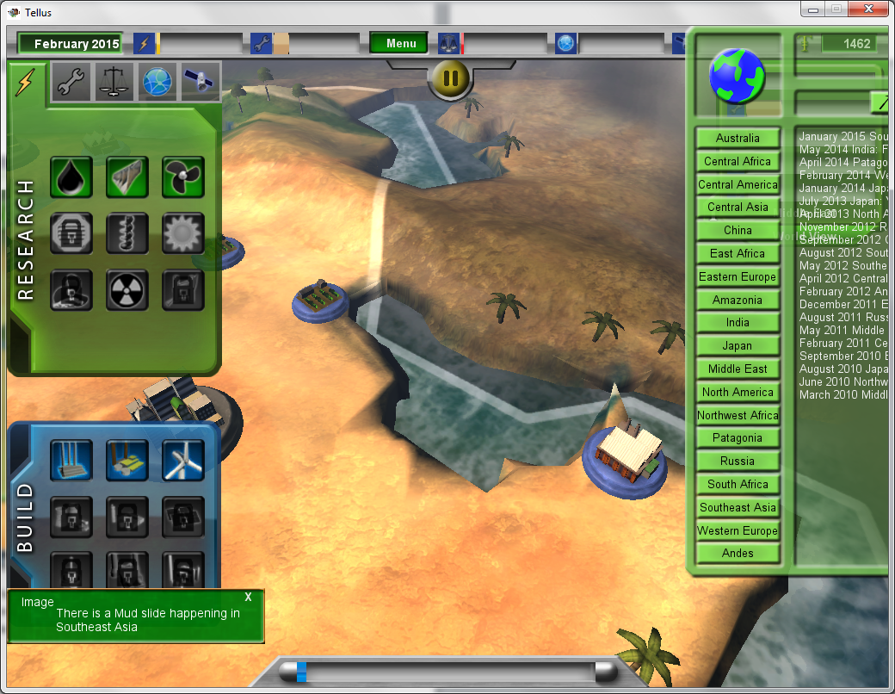
Similarly, if the player moves the window to the far right, the majority of the window leaves the viewable window. Severity Rating: Low.
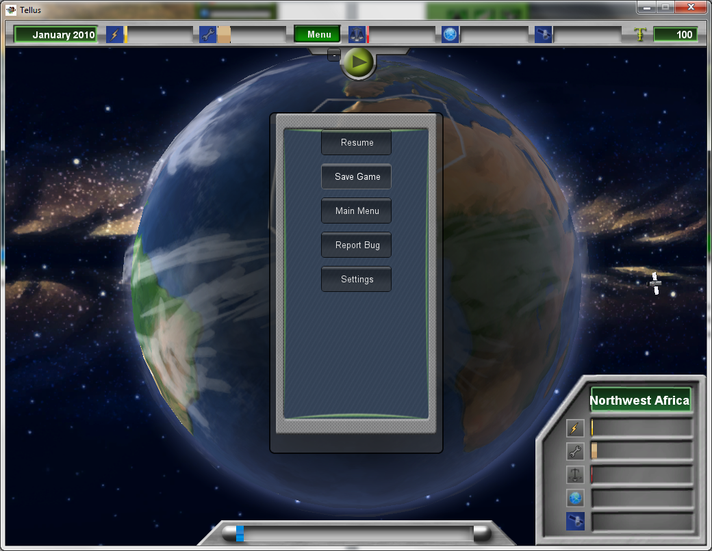
(Screenshot 1 of 3 of Save Game Bug)
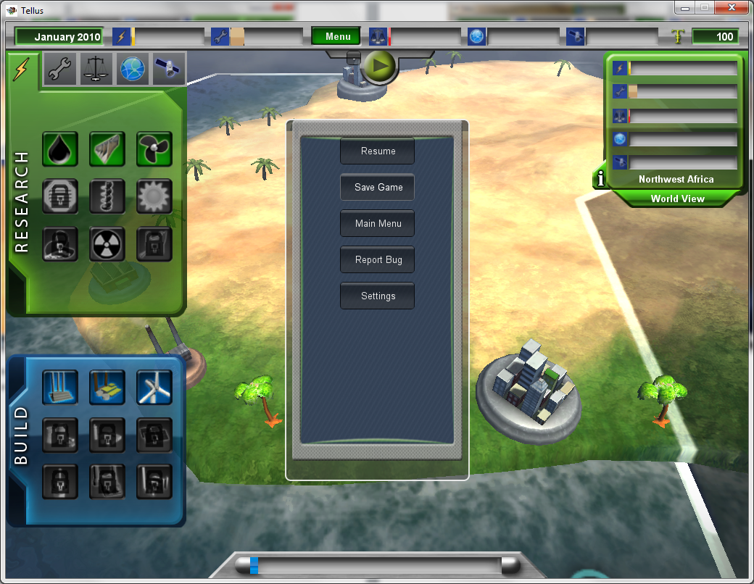
(Screenshot 2 of 3 of Save Game Bug)
In addition to the Save Game Bug; if the player has the Menu open, they can click on continents through the menu. Severity Rating: Medium.
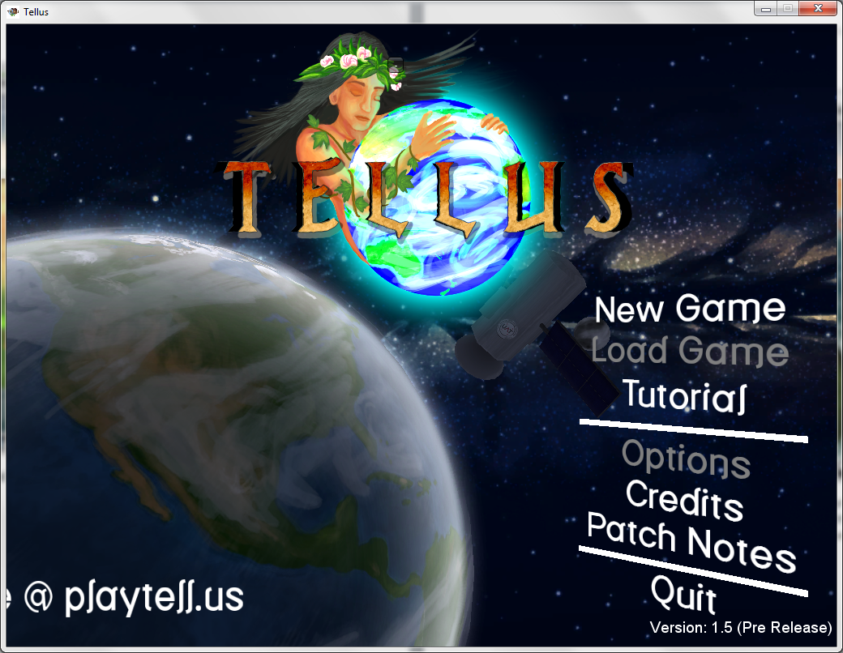
(Screenshot 3 of 3 of Save Game Bug)
On every single difficulty setting, the Save Game option in the menu does not work. The game does not save. Severity Rating: Urgent.

Gameplay Bugs:
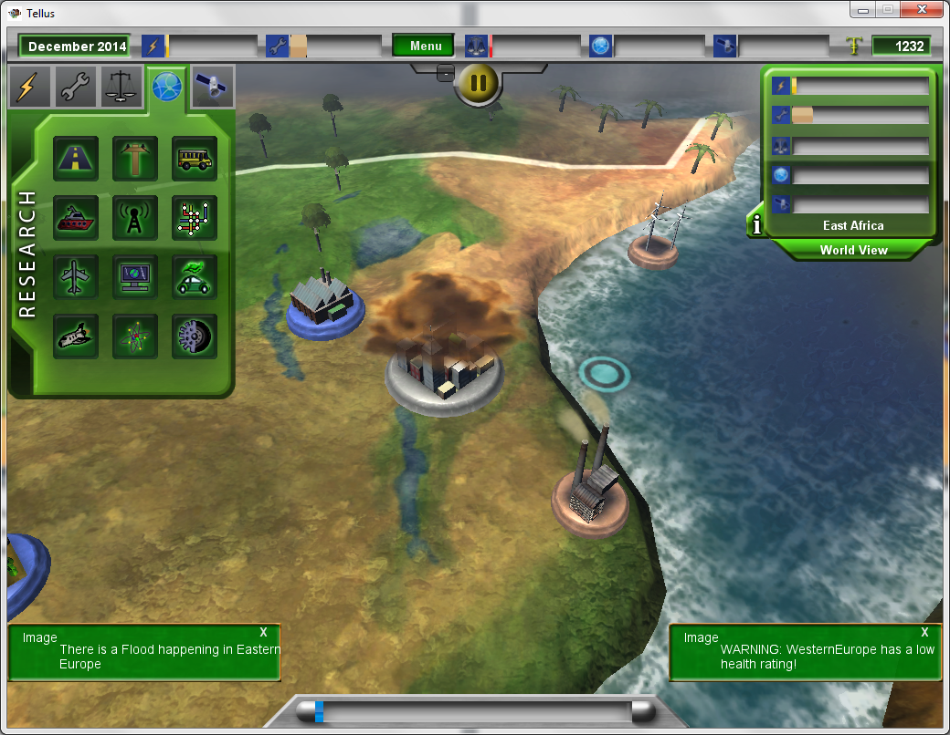
The only way to build new structures is if a portion of the map already has an open area or if the player demolishes pre-built buildings (although, those resources are needed to build new structures). It is impossible for the player to create new space on map locations. Severity Rating: High.
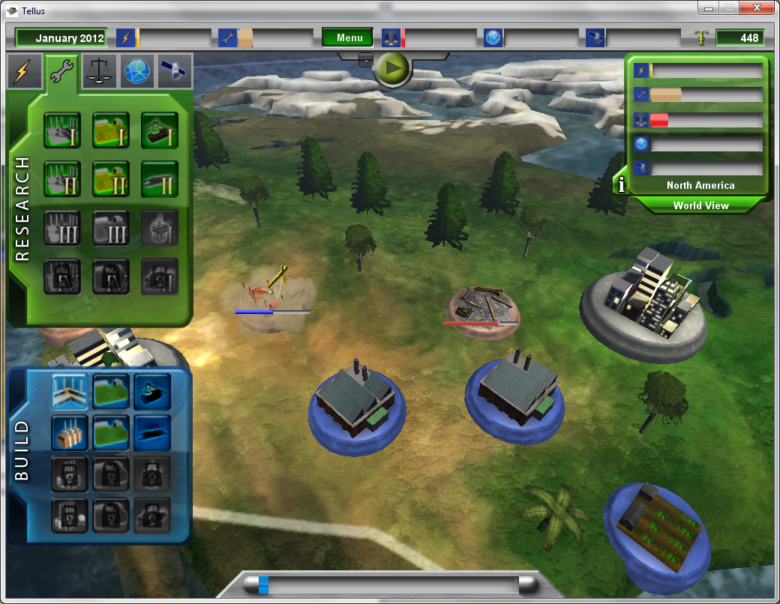
(Screenshot 1 of 2 of paused animation bug)
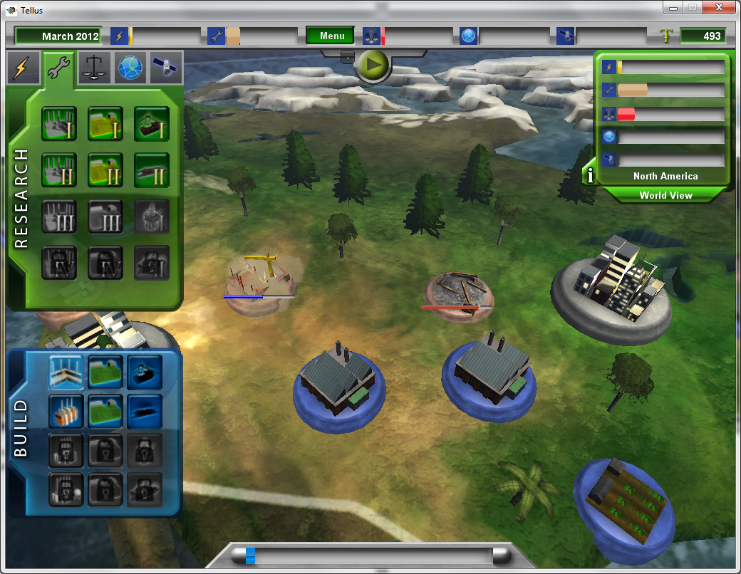
(Screenshot 2 of 2 of paused animation bug) Whenever a building is built or demolished, an animation plays on the buildings location. When the player pauses the game, everything freezes except for the building/demolish animations. Severity Rating: Low.
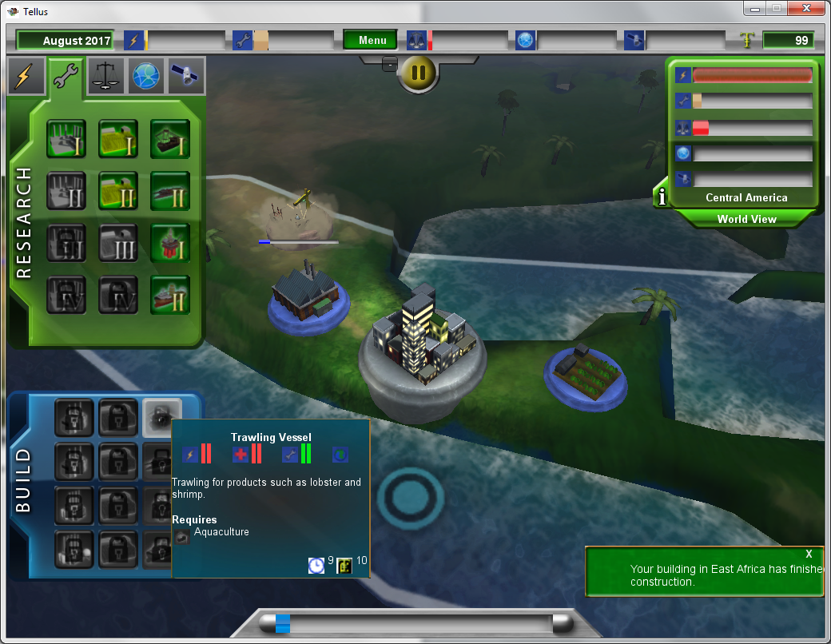
(Screenshot 1 of 2 of the research/building bug)
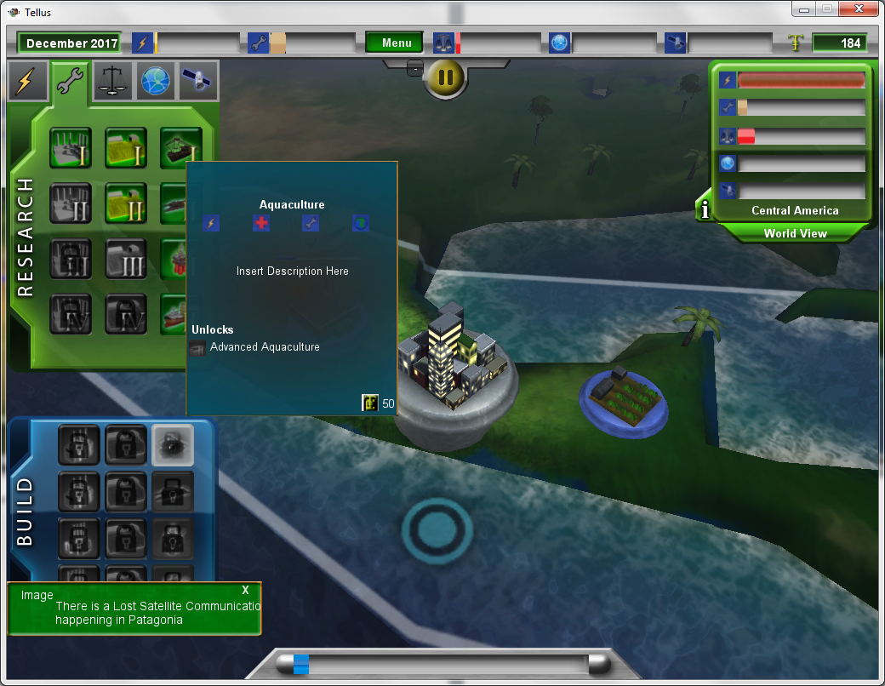
(Screenshot 2 of 2 of research/building bug) When the player tries to research the different farming skills in reverse, leaves the country, then returns to the country, the buildings are all locked despite having the necessary research skills already unlocked. Severity Rating: Medium.
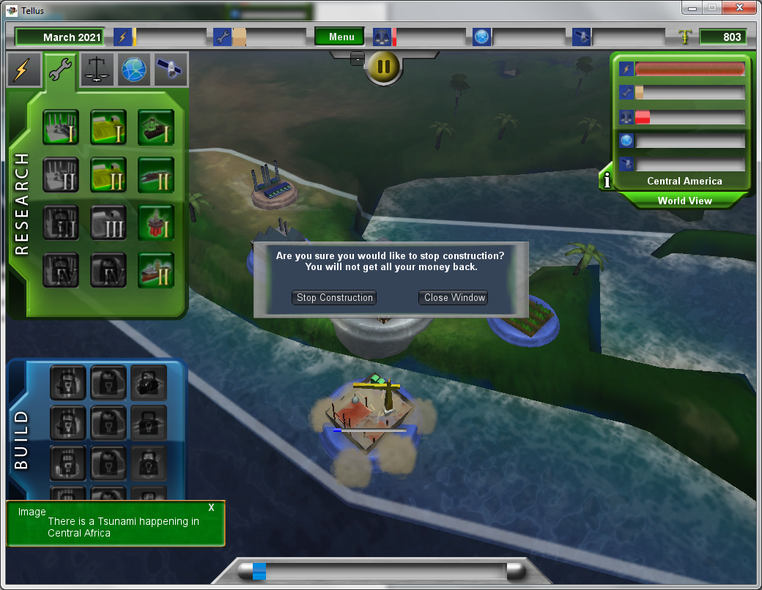
Despite the research/building bug, the player can still build all of the buildings. In this case the Trawling Vessel can be constructed, despite having them being locked. Severity Rating: High.
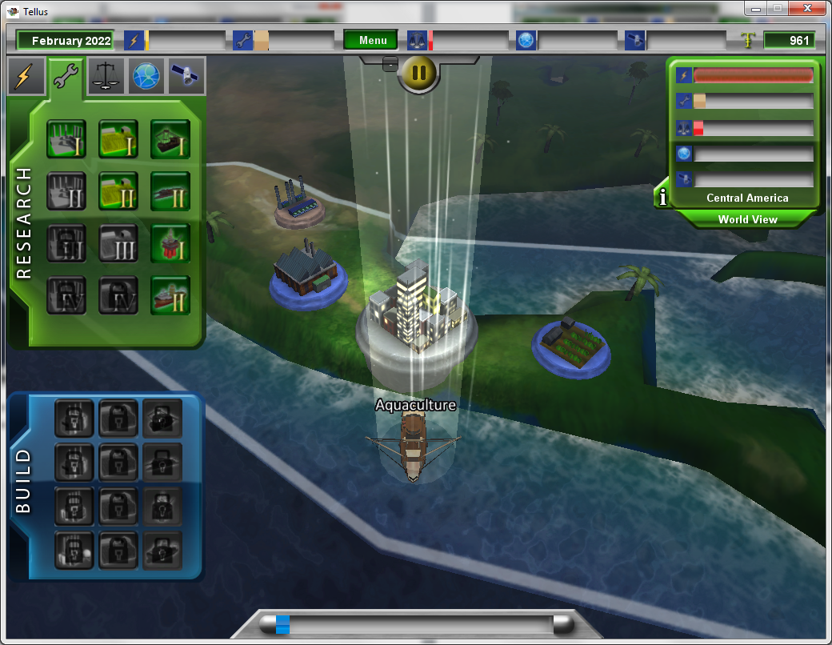
The result of the two bugs above results in the Trawling Vessel being labeled as “Aquaculture” on the 3D map instead of “Trawling Vessel”. Severity Rating: Medium
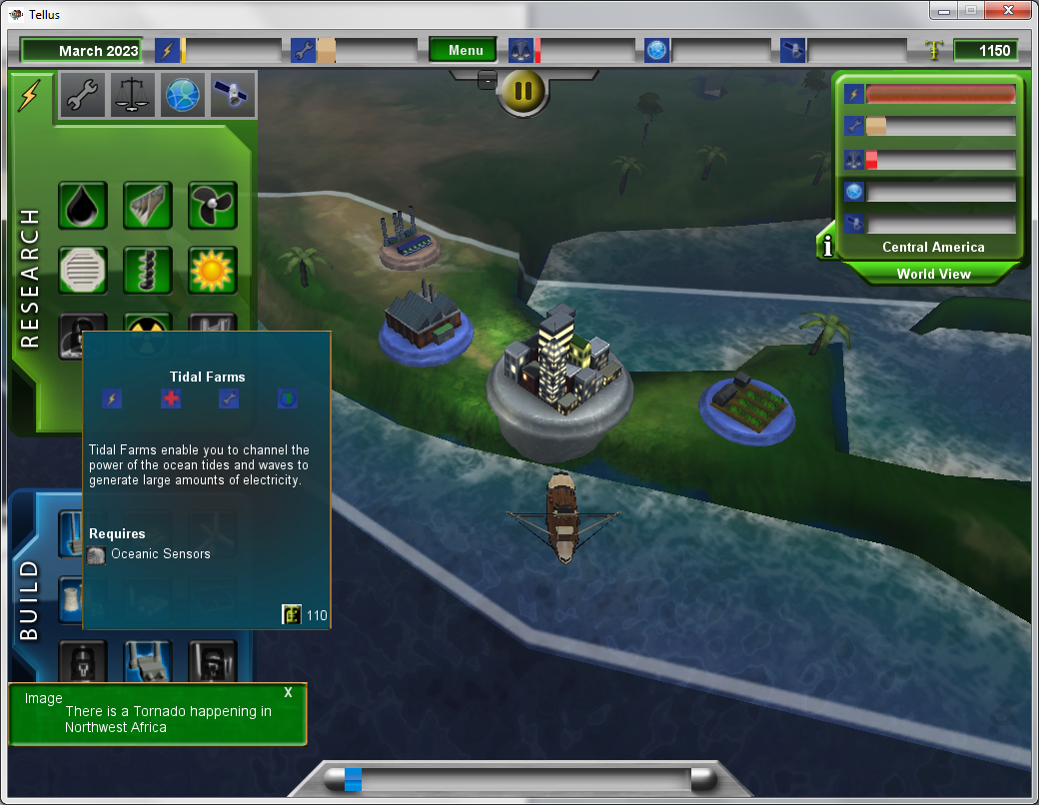
Oceanic Sensors are required to build Tidal Farms; however, Oceanic Sensors do not exist in any menu. Severity Rating: Urgent; this restricts the player’s ability to increase the quality of life meter and beating the game.
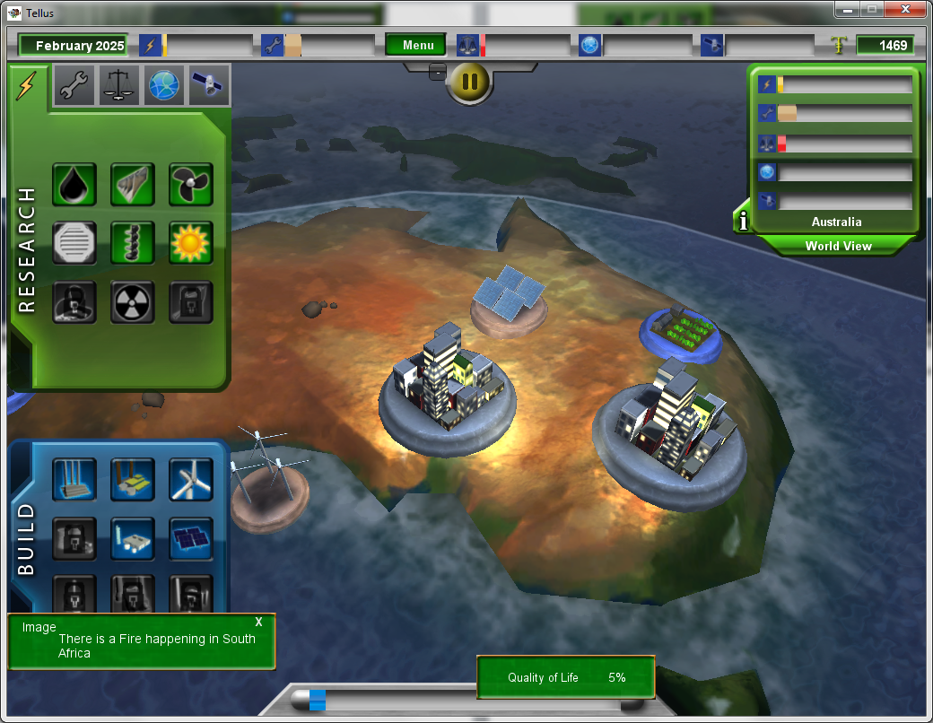
(Screenshot 1 of three of Quality of Life bug) See screenshot 3 for explanation.

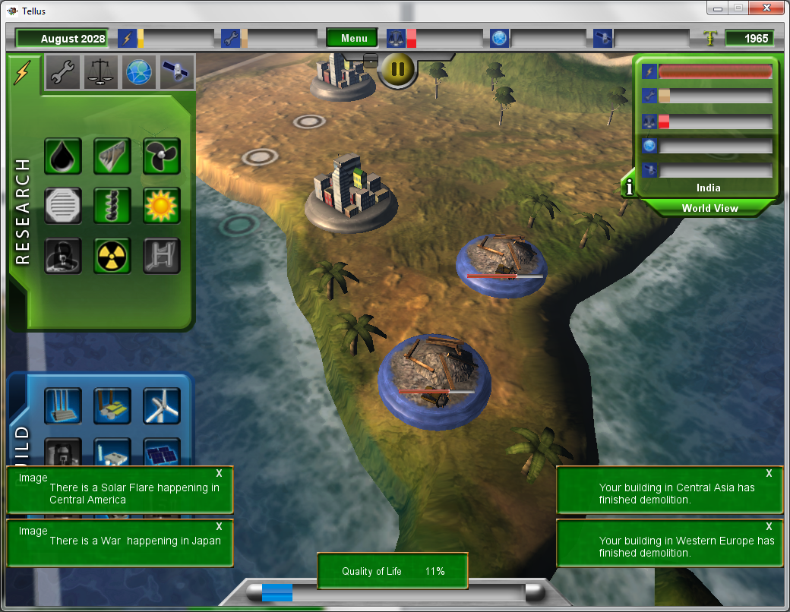
(Screenshot 2 of 3 of Quality of Life bug)
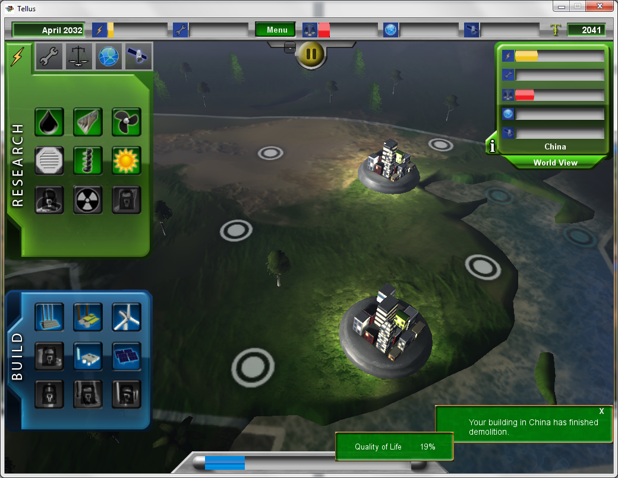
(Screenshot 3 of 3 of Quality of Life bug)
Even though the objective of the game is to increase the global quality of life by building structures and researching technology, if the player demolishes all buildings on the map, the quality of life will have the most rapid increase than if the player played the game as intended. Severity Rating: Urgent.
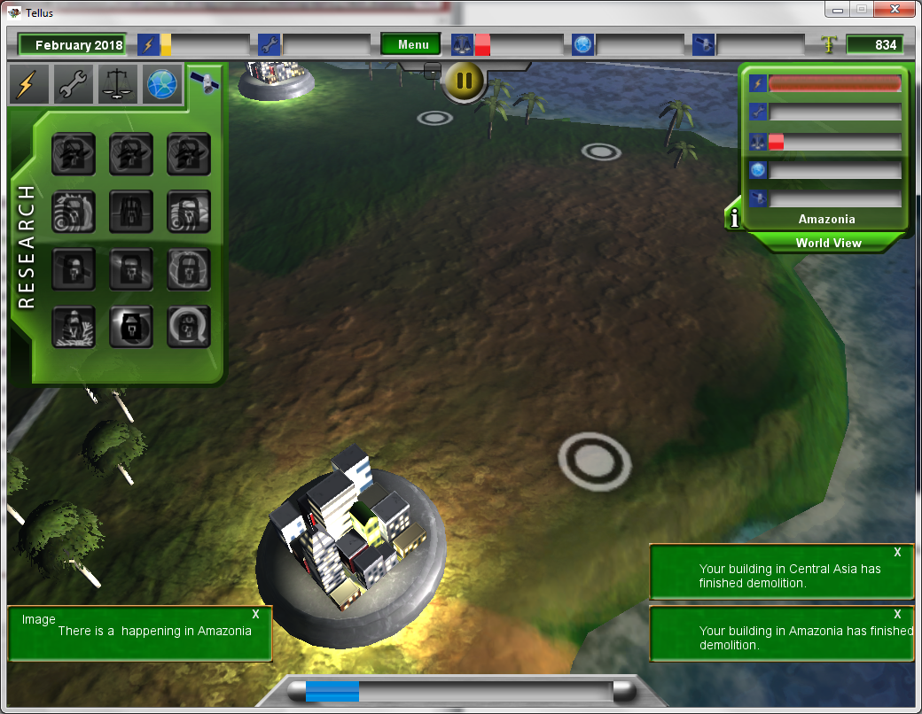
Periodically, the game displays updates/world happenings message in the bottom left corner (Pictured is a message that states “There is a happening in Amazonia”). Some messages have spelling/grammatical errors like the one pictured above. However, all of the messages take you to a part of the world where the occurrence is happening, but nothing changes in regards to Quality of Life in said region. Severity Level for spelling: Low. Severity Level for no gameplay consequences: High.
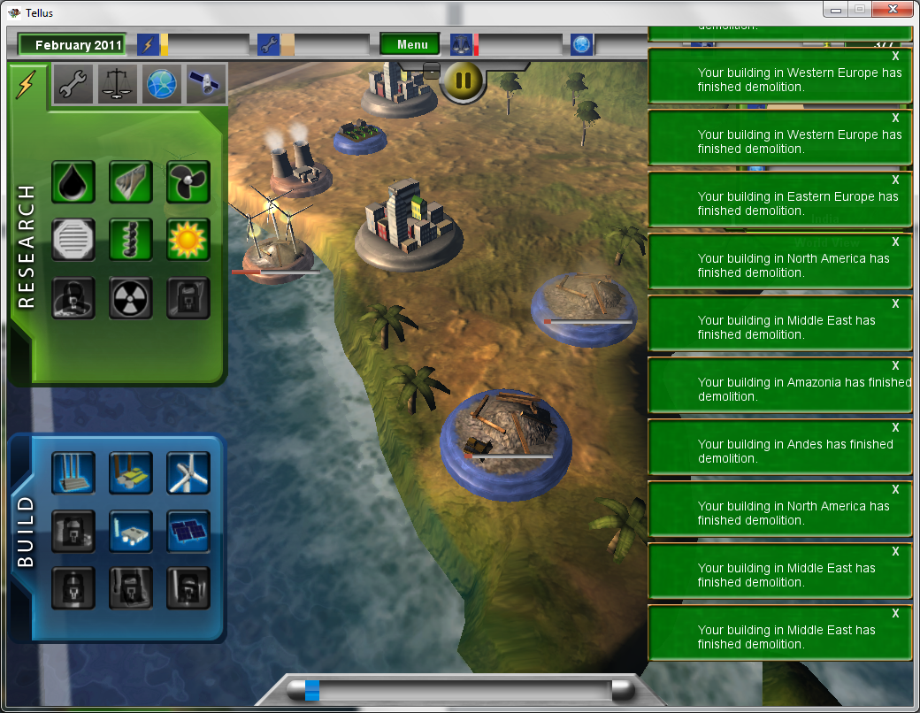
When there are too many reports, they go off the screen and the player is unable to read them and the player cannot interact with the world view menu unless they close every box blocking and above the menu. Severity Level: Medium.

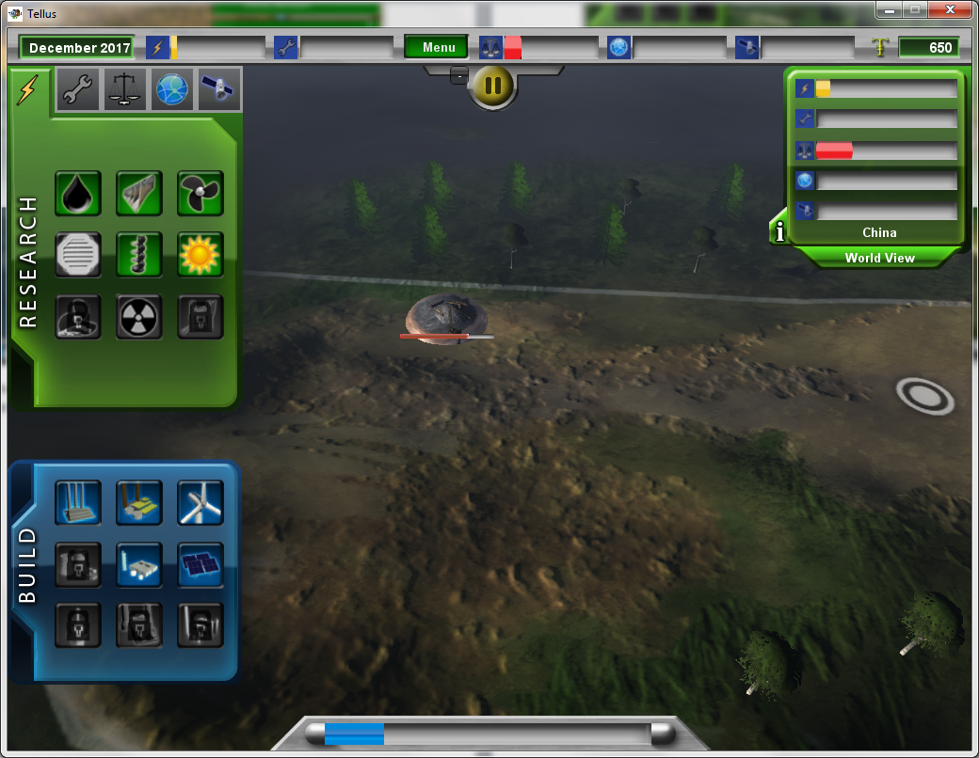
(Demolition glitch screenshot 1 of 2)
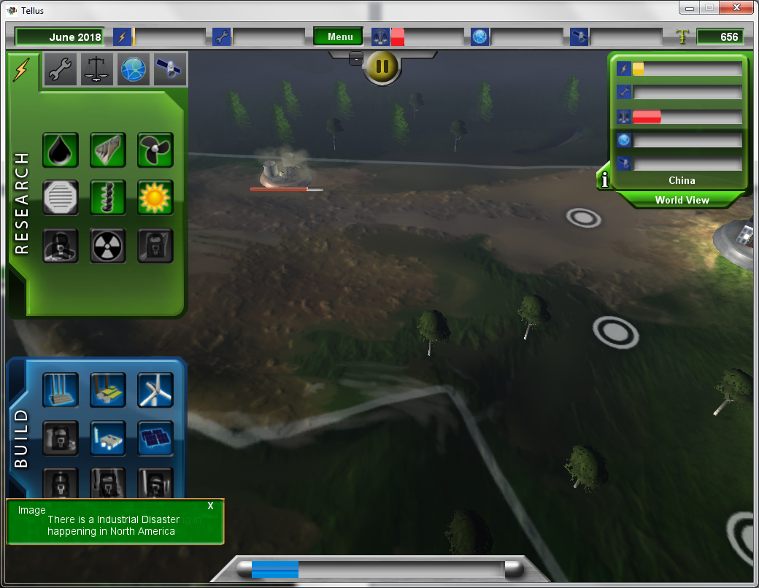
(Demolition glitch screenshot 2 of 2)
If the player chooses to demolish a structure in a portion of the map, leaves the area to either the world view or another section of the world, the demolition animation will restart. Severity Level: Medium.

