Left 4 Evil Dead 1

Gametype
- Single Player or Multiplayer? – Multiplayer
- Game Type? (DM, Capture the Flag, Assassination, Warfare, Hostage Rescue, Traditional RTS, Platformer, etc.) – Scavenge Mode
- What game is this map for? (UDK, Starcraft II, COD, etc) – Left 4 Dead 2

Story
- Story behind your map. Why are the players there? Why is the place/environment there? Write the history of your environment. What happened to the place before the player entered the environment? – Coach, Rochelle, Nick, and Ellis are in a remote cabin in the woods. There they discover a tape recorder that a professor had used to record incantations from the Necronomicon XMortis – the Book of the Dead. When they turn it on, the recording releases a dark, sinister force from the woods. It unleashes horde after horde of undead infected upon the survivors. Now our heroes must refuel their 1973 Oldsmobile Delta 88 and escape or become… Dead by Dawn!
- What is this map about? – The survivors try to collect gas tanks and fuel up the car for points as the special infected attempt to kill the survivors. The map lasts for a best 5 five match system, the team with the highest points win. After each round the players switch teams/roles.
- Every player at every map/level has a goal/desire/object and it is either fulfilled or denied/blocked/obstacle. Do you have this? Does it rise? This is especially important in Single Player maps. – The survivor’s goal is to collect all 16 fuel tanks. More dangerous/father away gas tanks are also near desirable weapons and power ups to further the risk/reward system in the map. The special infected’s goal is to simply kill the survivors so they have a better chance of getting a hirer score when they are playing as the survivors.

Gameplay
- What is the objective of your map? – Kill, survive, collect points.
- Do you have a top down game play sketch? - 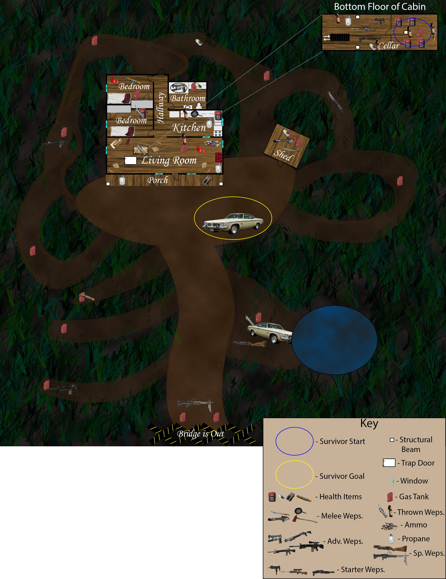
- Will there be any puzzles? If so, what are they? – No, just navigational routes to get to the gas tanks and better weapons/power ups.
- How would the level play out? Gameplay wise? – Frantic panic and lots of pew pews.
- How would you want the player to play through your map? Visualize this. What experiences do you want the player to walk away with from your map? – I want the survivors to be rushing to gas tank after gas tank working together and/or creating a daisy chain to get the tanks to the car for points. I want the special infected to be sneaky and surprise the survivors.
- How big is the map? – Relatively small be it feels larger because the survivors have to venture out from what would feel like the safety of the cabin in order to win the game.
- Who is your audience? Who is your player? What is your Demographic? – Fans of Bruce, The Chin, Campbell, and Evil Dead fans.
- How will you make the map memorable? – By bringing the amazing horror experience of The Evil Dead into an interactive horror experience.
- Do you have basic top down view and few location concept sketches? - 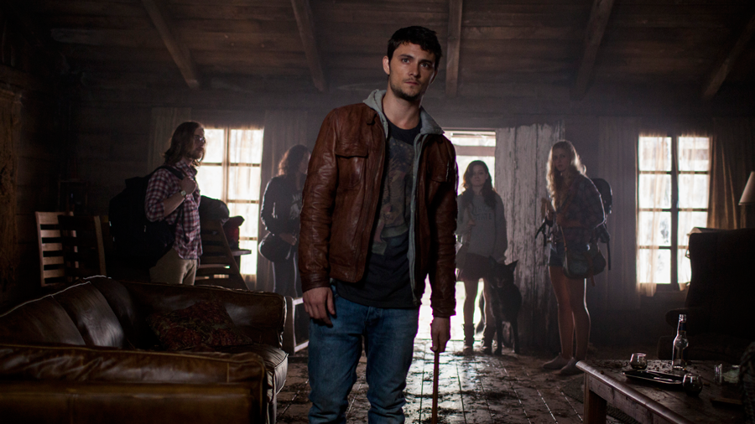 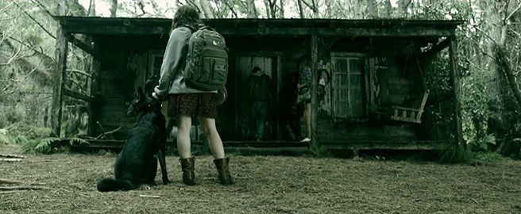 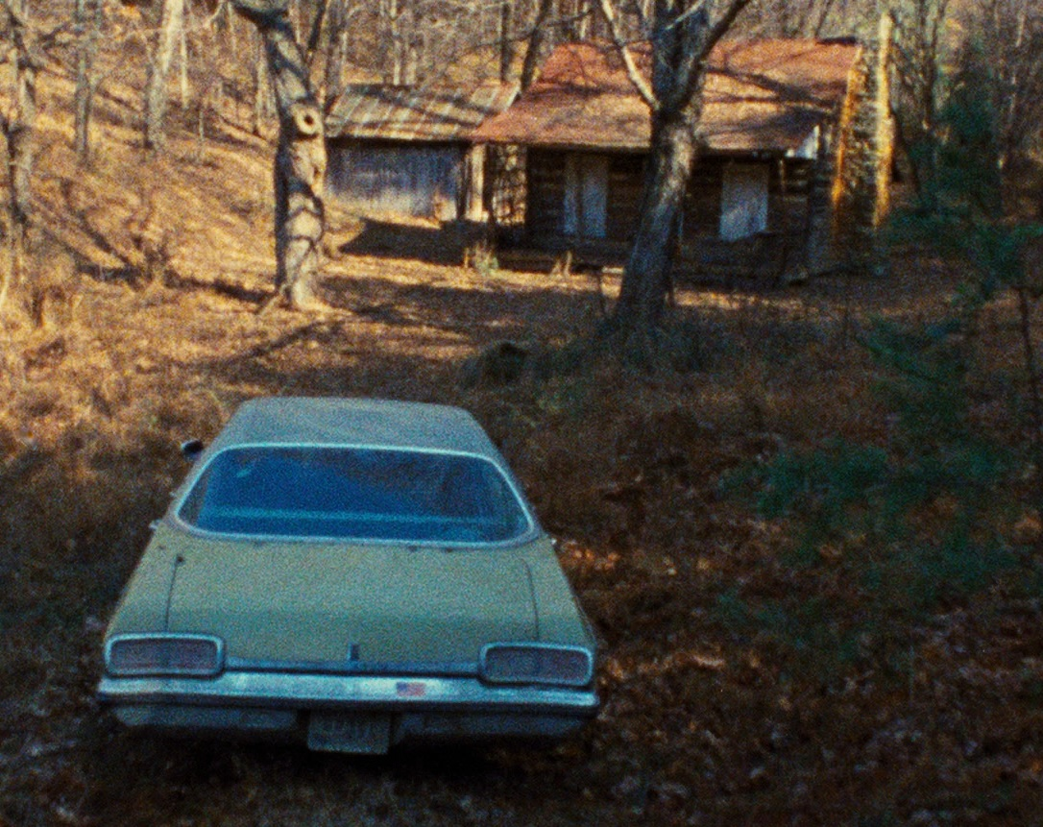 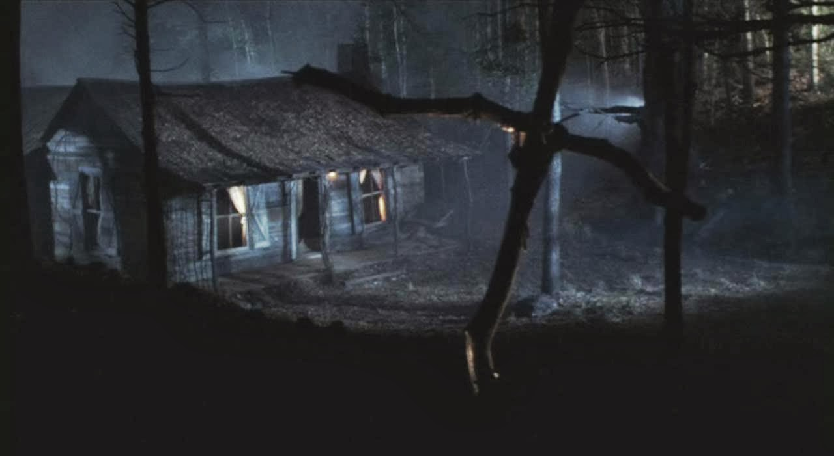 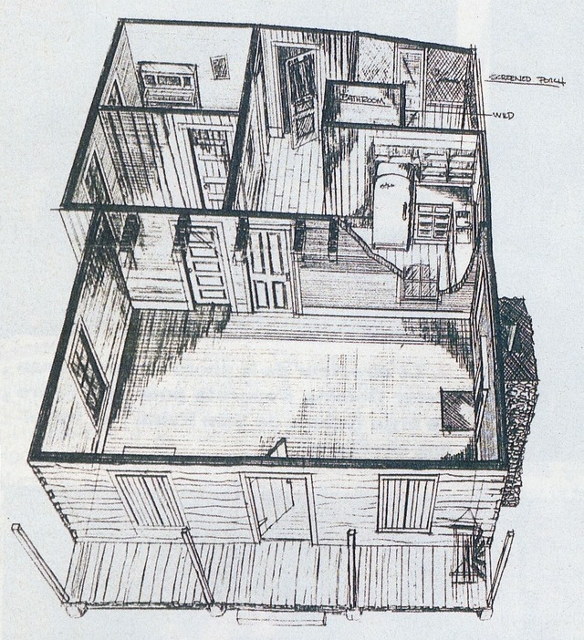 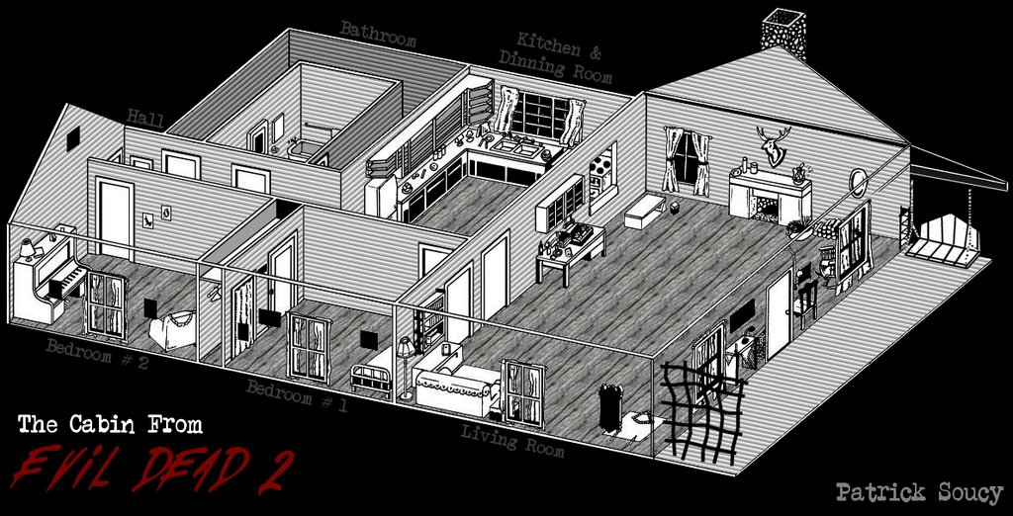

Visuals
- Is the map original? What is everyone else doing? Don't make another "everyone" map. Be original and different. How will you achieve this? – There are no custom Scavenge Maps on the PC L4D2 server list. Most L4D2 maps are made to look like the Legend of Zelda, Minecraft, or Dawn of the Dead.
- Reference. Have you collected all the inspiration and research? What is this going to look like (proof of visual development). - See above
- What is the time of day of the map? Season? Color? Reference. – Sundown, see above
- Feel and Atmosphere. Describe what you want to portray in terms of the feel of the map and atmosphere. – Frantic zombie panic!
- Will exploration be rewarded? If so what will it be and in what way? – Player’s reward for exploration will be power weapons additional aid/health items, and movie references.
- How will you direct the player? What methods will you use? Color? Noise and Sound? Guide the player without telling them where to go. Smart design. – Built-in functionality of L4D2 gives the players a highlight outline of where all of the gas tanks are.
- What are you going to concentrate on? What do you want to learn when you are finished? What aspect of design, gameplay, fun, crazy, atmosphere? – Fun and frantic competitive gameplay
- What is the visual trademark of your level? How will the players remember your map? – The Evil Dead.
- Are the environments/locations too generic? How does their design strengthen the story? – The cabin in the woods concept is a staple of horror and will enrich the overall terror experience.
- Custom content? Textures, Models etc. If so, what are they. – If I can figure it out I will be using custom sound to make the level more authentic.
- Have a drawn map of the level, below is an example:

