Los Malditos Penitentiary - CTF built using UDK3

**Gametype**

Los Malditos is a Capture the Flag map that could theoretically be inserted into an FPS game that included a prison setting. Los Malditos will be developed in UDK3 because UDK already contains several assets and mechanics, perfect for First-Person Shooter Capture the Flag game types. Since Los Malditos is a CTF map, it will be multiplayer. Also, in order to best balance the map based on its small size, each team will be comprised of four players. The demographic that we are targeting with Los Malditos is 12 - 25 male and female players because this target audience comprises the majority of market sales in this genre.

**Story**

The inmates of the Los Malditos Penitentiary have rioted in response to the warden installing a furnace feeder in the middle of the cafeteria. After the riot, several cell blocks were destroyed and have since been blocked off for repairs. Unfortunately, this has lead to massive over-crowding within the prison and the guards have decided to force the inmates to play a deadly game of capture the flag for their amusement; as well as, cut down on the prison population. Unfortunately for the player, they are one of the lucky inmates selected to play. In order to survive and live to see tomorrow, they must kill the opposing team's inmates and capture their flag three times.

**Gameplay**

Los Malditos is a team-based CTF map; players must defend their own flag and capture the enemy's flag in order to win the game. Players are expected to either play defensively and/or offensively to accomplish this goal. To aid them, weapons, ammo, and health are placed strategically throughout the map along the five main routes around the map. A player's ability and their teammate’s ability levels will greatly influence the impact of how quickly a team can win. Additionally, knowledge of the map will also play a key variable in the game's outcome.

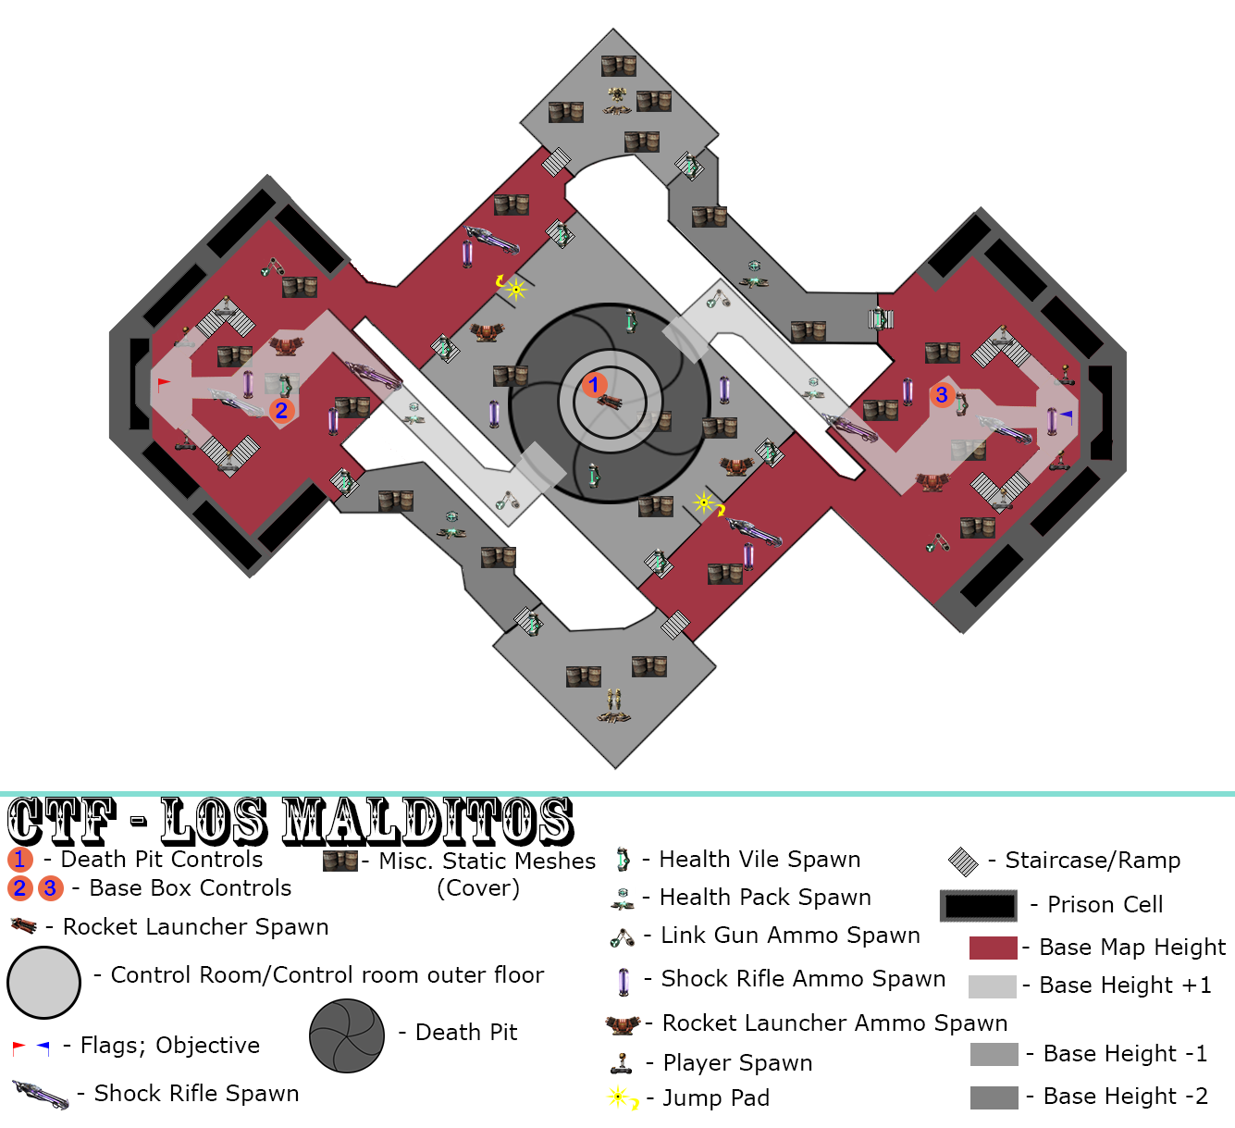

Los Malditos Paper Map

Additionally, the map contains a death pit which is controllable by players via a control room panel that floats above the death pit. Also inside of the control room is the rocket launcher. The decision to have only one entrance/exit into the control room and to have the rocket launcher spawn there is to heighten the sense of risk/reward. While players are rewarded with the most powerful weapon and the ability to open the pit and kill anyone unfortunate enough to be caught in the mayhem, players put themselves at great risk as they can easily be shot in the back and killed by another player.

In order to entice players to traverse over the death pit while it is closed, a power-up item is located in the center of the pit. These additions again adds to the risk/reward system for the map by encouraging players to both take chances, and try and kill other players with the death pit. Players will also have the ability to move some static meshes in their respective base via a terminal (done in kismet) in their base to add another dynamic layer to the map.

**Visuals/Effects/Audio**

The inspiration for this map comes from the Halo 4 map: Adrift and the Kyln prison from Guardians of the Galaxy. Using these as references the textures will be dark and metal looking, along with some concrete textures. However, the map will be well lit so players can see in all areas of the map. The intension is to create an intense and pseudo-futuristic/realistic environment for players to enjoy while fragging each other. The major draw of this level will be the symmetry that draws players to the central room which contains a giant death pit. The death pit is controllable by players via a control room panel that floats above the death pit. Also inside of the control room is the rocket launcher. The decision to have only one entrance/exit into the control room and to have the rocket launcher spawn there is to heighten the sense of risk/reward. While players are rewarded with the most powerful weapon and the ability to open the pit and kill anyone unfortunate enough to be caught in the mayhem, players put themselves at great risk as they can easily be shot in the back and killed by another player.

**Reference Images**

http://www.343industries.org/Halo-4/_/multiplayer-maps/adrift-r14

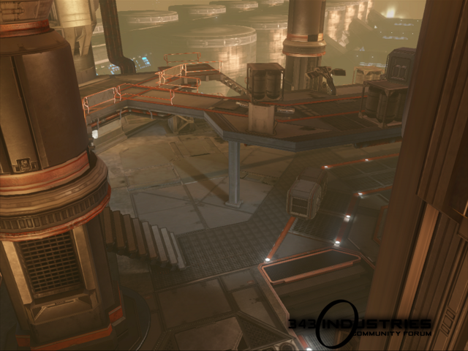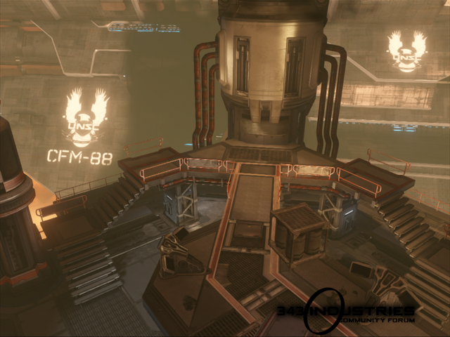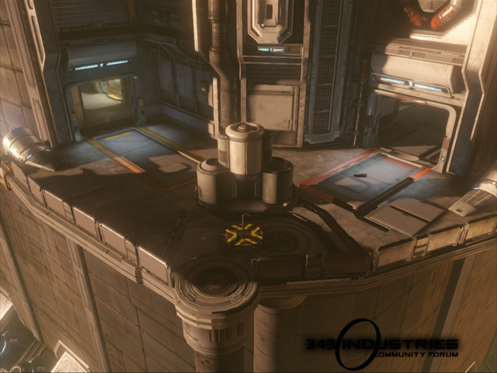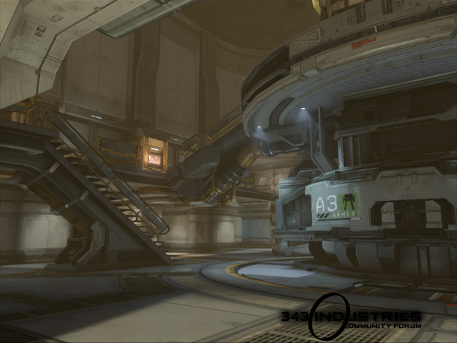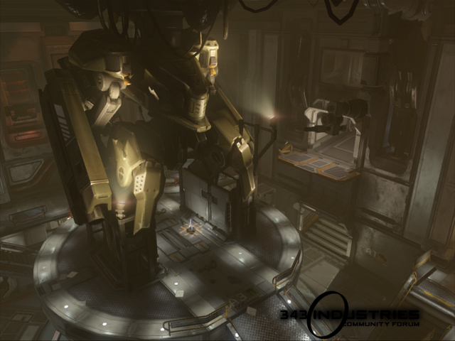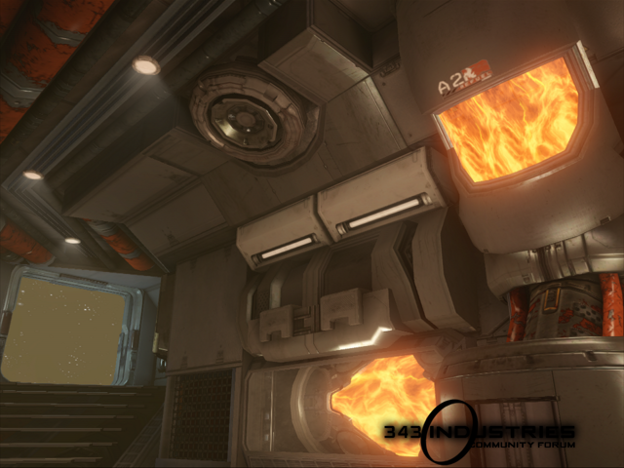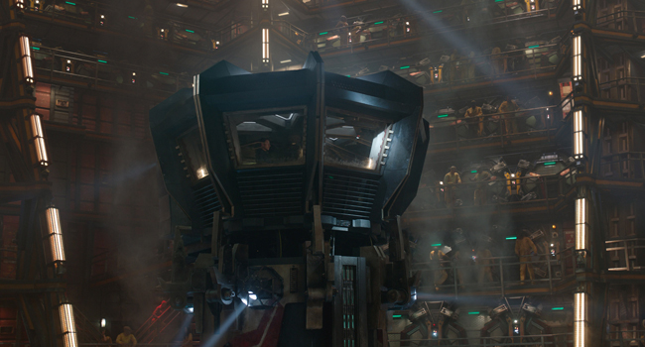

# CTF - Los Malditos Asset List

|  |  |  |
| --- | --- | --- |
| **Name** | **Priority** | **Completed** |
| Cafeteria Tables | Moderate | No |
| Shower Static Meshes | Moderate | No |
| Security Room Static Meshes | Moderate | No |
| Prison Cells | High | No |

# CTF - Los Malditos Feature List

|  |  |  |
| --- | --- | --- |
| **Name** | **Priority** | **Completed** |
| Matinee controlled doors | Moderate | No |
| Matinee controlled moving boxes in base | Low | No |
| Matinee controlled death pit | Critical | No |