# A Pocketful of Nuyen - A Vertical Slice Shadowrun Returns Campaign

**By Derek Sinex**

**Gametype**

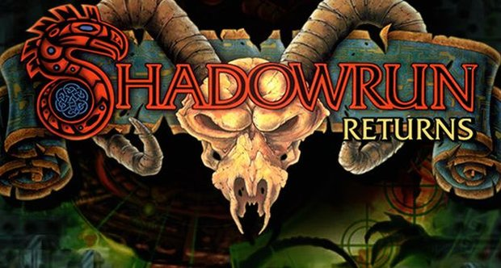

This map will be created using the Shadowrun Returns editor, for Shadowrun Returns. As such, the map is a single player Action RPG map. With the target audience being the Shadowrun Returns core market.

**Story**

The three family heads (bosses) of Tureen Industries, one of Seattle's leading tech corporations, suspects a mole inside of their organization. The player is called in as a favor by the head of the elven family to conduct an independent investigation since all three families suspect the other of being the mole. The player then goes on an adventure gathering clues and as they get closer to uncovering the mole's true identity, the family boss' private dealings lands the player in the middle of a much larger corporate scheme where they must use their wits and skills to escape with their lives.

The player is put into the shoes of a retired corporate security officer that is reluctantly brought out of retirement for one last consultant job. They must use both their character skills during conversation trees and their character's combat prowess in order to be successful through the map.

The player will experience the beginning of the story arch and follow the critical path to uncover the mole. If there is enough time once the critical path story arch is complete, alternative routes/branching paths will be built into the level. Regardless, the map will end on a cliff-hanger once the player gathers enough evidence to confront the boss who is most likely to be the corporations mole.

As corporations started to take over the landscape of future Seattle, three former crime syndicate families agreed to join together to form a legit corporation as their only means of survival in the new world. Thus, Tureen Industries was born from the cooperation of the Wiley, Kiev, and Shepherd crime families. In present day (future) Seattle, profit shares have suddenly plummeted for Tureen Industries as their largest competitor has released Tureen's latest and greatest prototype ahead of them. This turn in the corporate atmosphere has made the corporate bosses to become suspicious of one another. The head's of the company: Terrance Wiley - the Human family head, Jazon Kiev - the Elven family head, and Leoric Shepherd - the Dwarven family head, have agreed that the only course of action due to an oversight in their Information Governance policies is to hire an outside contractor.

Kiev sends a message to the player, a retired security expert who has helped and been helped by the Kiev family on several occasions over the years, requesting they be the outside contractor as they are the only one he can trust. The player reluctantly accepts on behest of repaying a final favor for Kiev's recently deceased father; and a boat load of Nuyen. The player ventures to Tureen Industries to meet with the three heads to get a first impression of the situation as all three bosses seem to have ulterior motives and are untrusting of one another due to racial bias and a long history of violence between the families in the olden days.

Once the meeting is over the bosses grant the player the highest level of access in order to get to the bottle of the leak. The player progresses after the meeting by going down to the security office, gaining intel from either the security office or hacking into the company's server via security terminal. They also receive some combat training and equipment from the chief security officer. The intel they gain leads them to the R&D department where they again critical information from the head of R&D, Sheila, and Dr. Jonas - the corporation's lead developer which leads the player to smooth talking the three bosses secretaries. The player gains sensitive information on Wiley, the Human boss and Leoric, the Dwarf boss which could lead to either one being guilty at this point. However, for the critical path and to limit scope the player can only pursue the Wiley route (unless time permits) because his regular secretary, Abby, is mysteriously home sick from work. The player travels to her apartment to find her physically injured and packing a "go back" to leave Seattle. Upon further inquiry the player discovers that Wiley has deferred his immense gambling debt to Abby and she is skipping town to avoid the mafia run casino in town. At this point the player is alerted to a strange noise in the back of her apartment. The player can pursue the noise further which reveals gangsters hiding in the back of her apartment which initiates combat, or the player can leave. Leaving results in the secretary being killed by the gangsters.

With this new information in hand (Wiley's gambling troubles) the player travels to The Little Gamblino Casino. Upon turning in the information about Wiley to a pit boss, the player is escorted to a back room where Wiley is conversing with the mob boss-owner of the casino. Wiley has sold prototypes off to their competitor and reveals that he used some extra Nuyen to have the mafia "relocate" the player as they are the only person left that knows the truth about the information leak. Wiley leaves to grab the last of his things from the office before leaving Seattle and working for their competitor. The player can attempt to talk their way out of the situation depending on their skills or take on the mafia in combat.

Upon complete this section the player races back to the corporate headquarters to confront Wiley in front of the other bosses. However, Wiley has put in a contingency plan and the player, along with the other two family heads must fight for their lives in order to stop Wiley.

**Gameplay**

For the critical path the player will start by going through the map's initial dialog which introduces the setting and goal for the player (discover who the corporate mole is and turn them into your employer). In order to play through the map, the player will have options to complete tasks through either dialog options or combat depending on their play style/character build.

For the critical path, there will be 7 total map locations; the majority of which will be fairly small as they serve as either CQB, dialog modular set pieces, or tutorial sets. Ideally it will take the player half an hour to complete the "full campaign" if they take their time to explore the dialog trees and each modular area, but if the player breezes through each modular set following the critical path they will complete the campaign in a lot less time. The map will not contain outright puzzles; however, the player will need to collect objective pieces to open up the next section which involves exploration and talking with NPCs. Furthermore, the player will be rewarded for using non-violent (dialog choices) routes to solving combative situations as the combat in Shadowrun Returns can be extremely unforgiving. However, the difficulty of the map will be predicated around the player creating a new character from scratch.

Since the map is set in the Shadowrun universe, the maps will be a combination of dreary futuristic dystopia and clean, surgical, corporate settings.

**Paper Map**

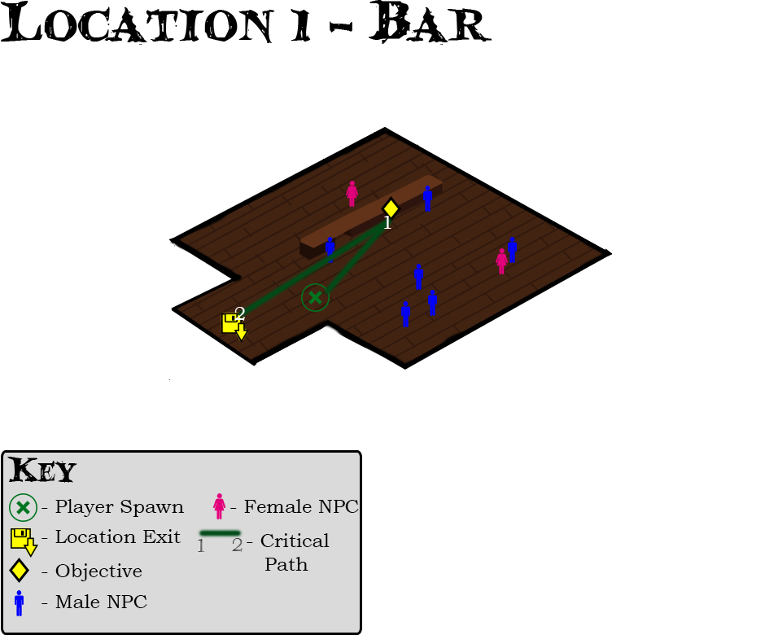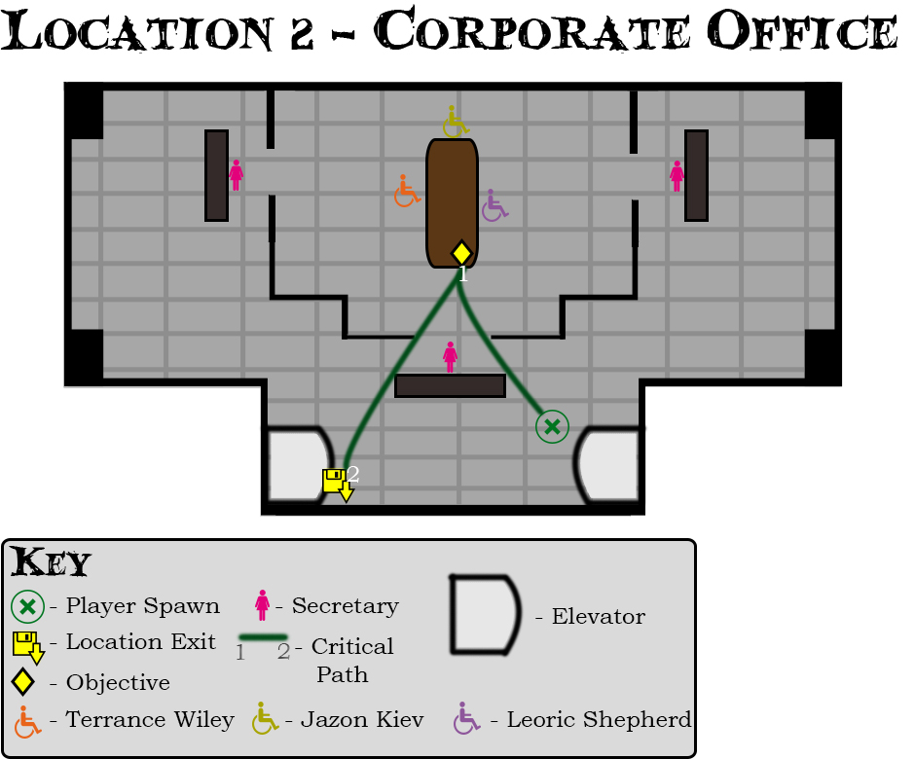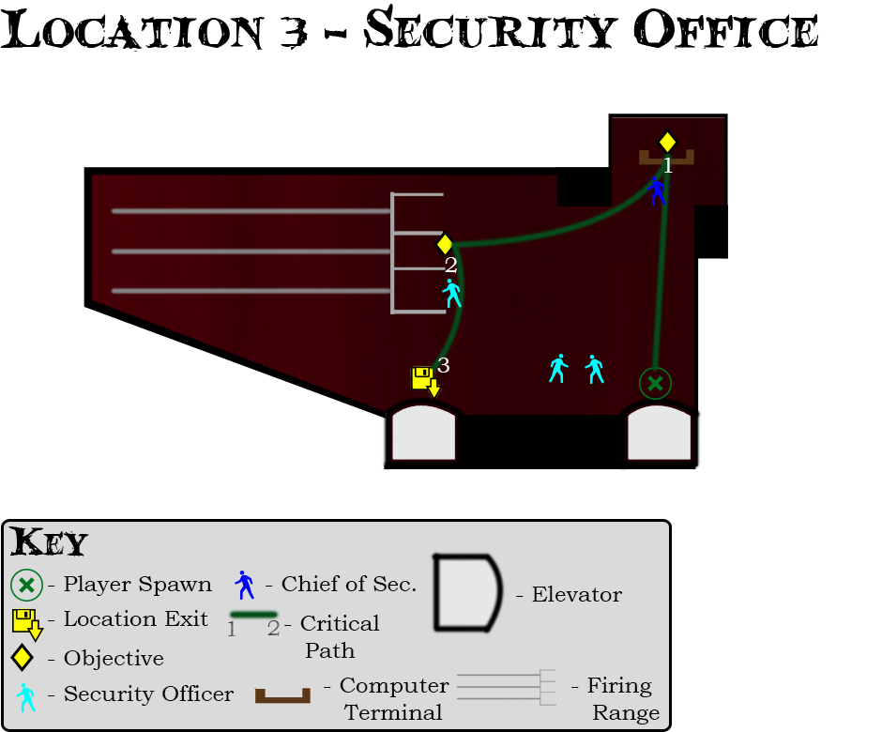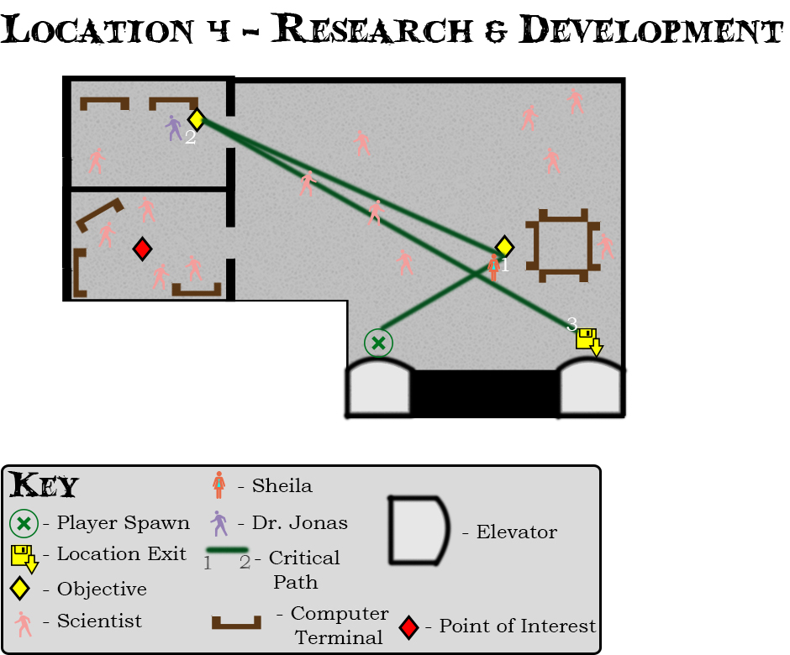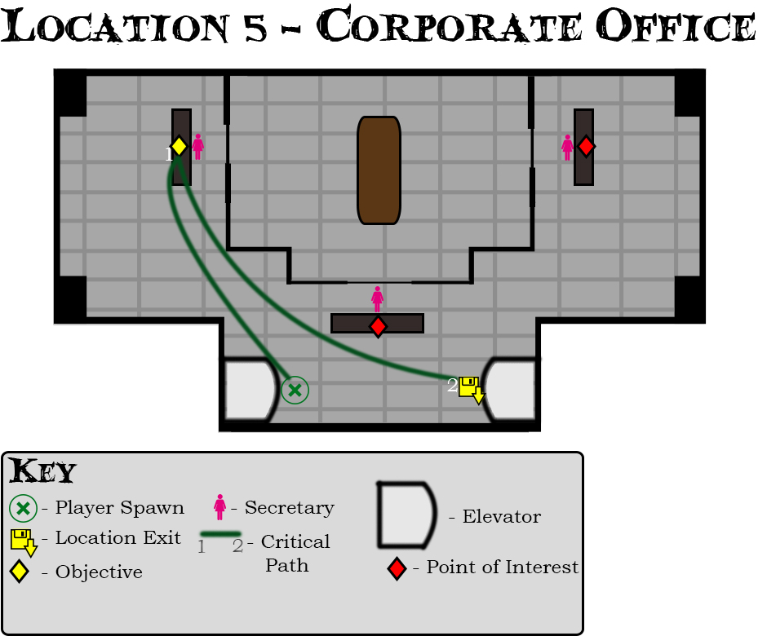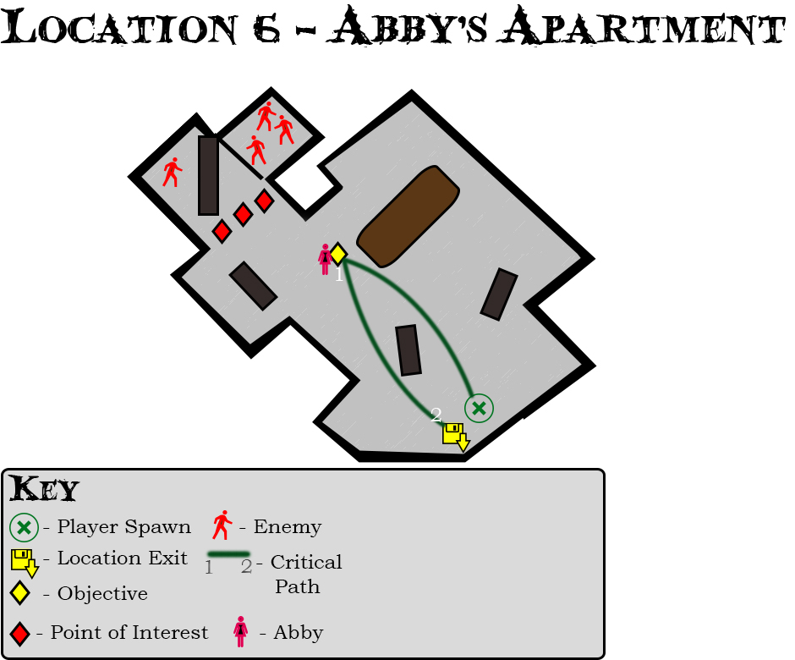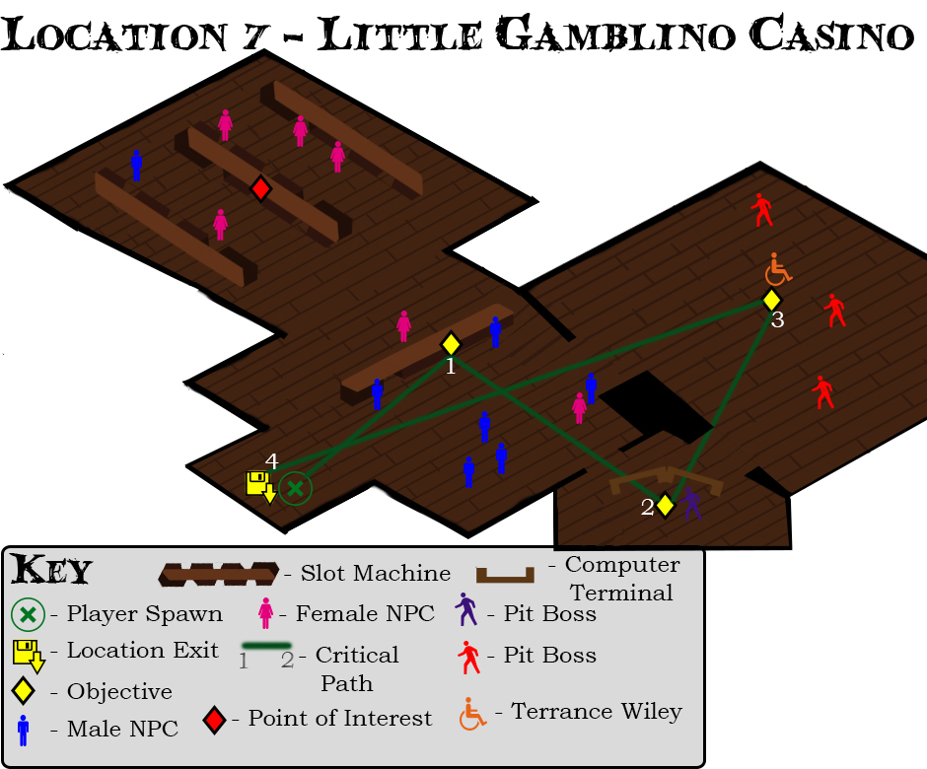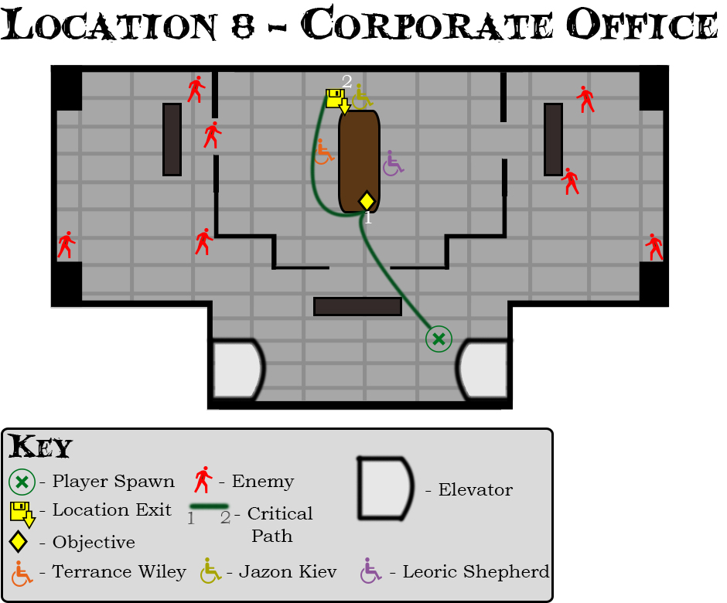

**Visuals/Effects/Audio References**

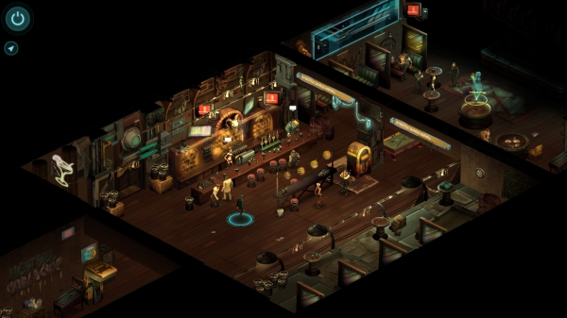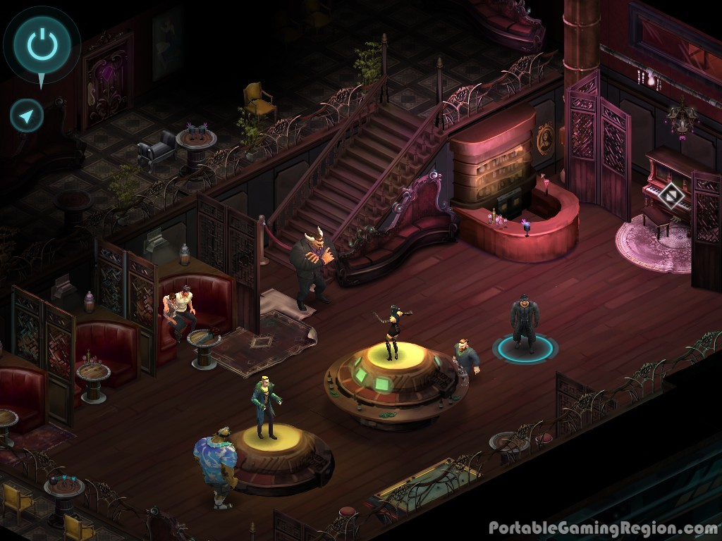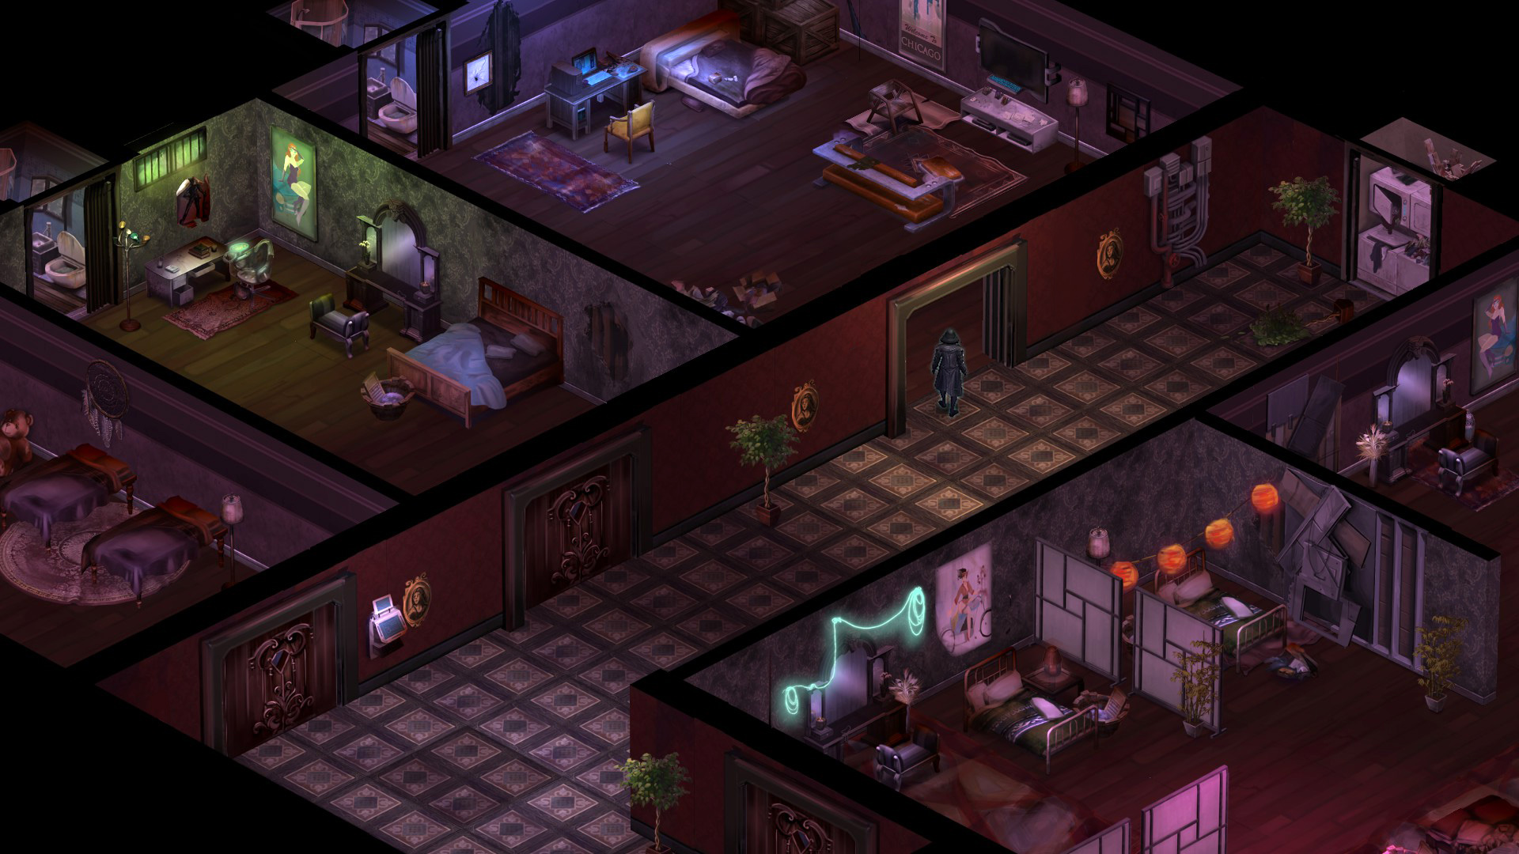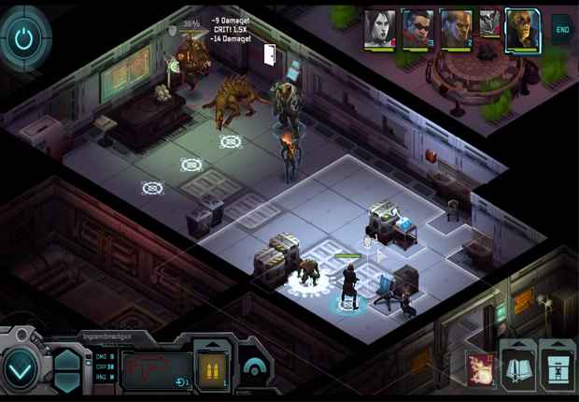

# A Pocketful of Nuyen Asset List

|  |  |  |
| --- | --- | --- |
| **Name** | **Priority** | **Completed** |
| Character Portraits | Moderate | Yes |
| Additional Tilesets | Moderate | Yes |
| Additional Props | Moderate | Yes |

# A Pocketful of Nuyen Feature List

The only scripts that will be created will be for handling the objectives, dialog trees, and combat triggers. Most, if not all of the scripting done will be handled by the engine or from easy to find tutorials on how to script them in-engine.